ML

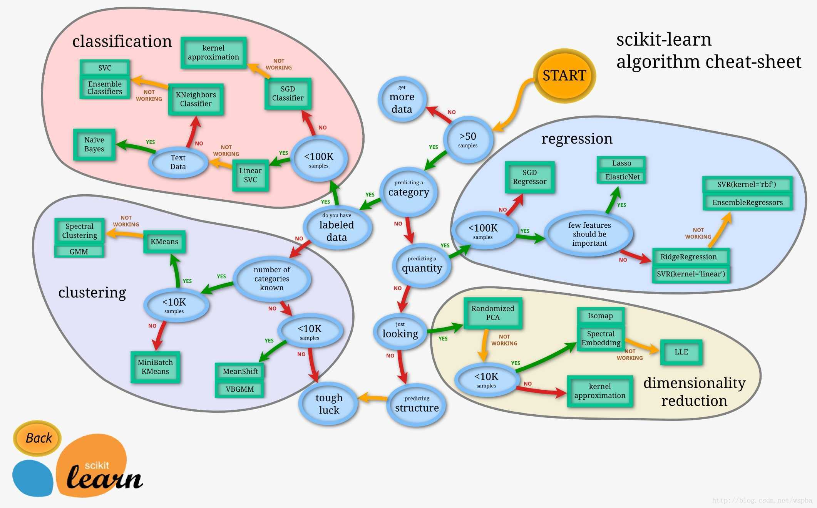

**Lesson 1**

① Supervised Learning (SL)

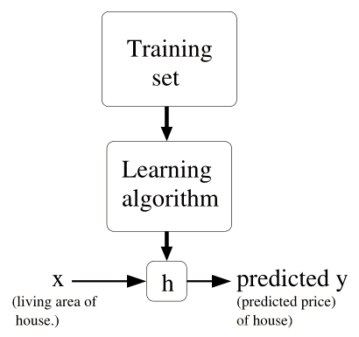

Continuous 🡪 Regression Question (to predict)

Discrete 🡪 Classification Question (to ‘chose’ whether or not)

② Unsupervised Learning (UL)

No comparative sets or no certain answer 🡪 Clustering

③ Reinforcement Learning (RL)

‘Good Dog’ & ‘Bad Dog’ Question 🡪 Maximize ‘Reward Signal’ (decision making, like SLAM)

**Lesson 2**

① Optimization Question 🡪 least square method 🡪 ***Gradient Descent Algorithm***

② GDA associated

$$θ=θ-α·∇_{θ}J(θ)$$

$α$ called ‘learning rate’, need to set by experience because too large can lead to go over the minimum, accordingly, too small can lead to convergent slowly.

(1) Batch gradient descent (e.g. linear regression)

.

**🡪** :

🡪🡪:

∴ *Batch Gradient Descent called*

$$repeat till convergence:$$

$$θ_{i}∶=θ_{i}-α·\sum_{j=1}^{m}{\left(h_{θ}\left(x^{\left(j\right)}\right)-y^{\left(j\right)}\right)·x_{i}^{\left(j\right)}}(for all i)$$

$$\left(θ can be initialized as \left[0,0,…,0\right]\right)$$

(2) Stochastic gradient descent (suit large quantities of training sets)

$$repeat$$

$$for j=1 to m$$

$$θ_{i}∶=θ_{i}-α·\left(h_{θ}\left(x^{\left(j\right)}\right)-y^{\left(j\right)}\right)·x_{i}^{\left(j\right)}(for all i)$$

‘accelerate’ algorithm, local minimize feature not as good as (1), just swing around it.

*(Q: How to check convergence? Any optimized solution?)*

③ Normal Equation

GDA iteration complex 🡪 Matrix-related presentation (trace properties & equation deductions)

$$∇ defination:$$

$assume$ $A∈R^{m×n}, f\left(A\right): R^{m×n}⟼R$

$$define$$

$$∇_{A}f\left(A\right)=\left[\begin{matrix}\frac{∂f}{∂a_{11}} & ⋯ & \frac{∂f}{∂a_{1n}} \\ ⋮ & ⋱ & ⋮ \\ \frac{∂f}{∂a_{m1}} & ⋯ & \frac{∂f}{∂a_{mn}}\end{matrix}\right]$$

$$especially$$

$$if A∈R^{n×n},$$

$define$ $tr A\left(or tr\left(A\right)\right)=\sum_{i=1}^{n}{a_{ii}}$

$$some useful properties:$$

①

🡪

②

🡪

③

🡪 ,

④ $∇_{A}tr ABA^{T}C =CAB+C^{T}AB^{T}$ ${\left(uv\right)}^{'}=u^{'}v+uv^{'}$

$$*brief proof$$

$$∇_{A}tr ABA^{T}C =∇_{A}tr ABA^{T}C|to A+∇_{A}tr CABA^{T}|to A^{T}=C^{T}AB^{T}+CAB$$

try to concise iteration by upwards definition & properties

$$define$$

$x\left(\vec{x}\right)=\left[\begin{matrix}x_{0} \\ ⋮ \\ \begin{matrix}x_{i} \\ ⋮ \\ x_{n}\end{matrix}\end{matrix}\right] Θ\left(\vec{θ}\right)=\left[\begin{matrix}θ_{0} \\ ⋮ \\ \begin{matrix}θ_{i} \\ ⋮ \\ θ_{n}\end{matrix}\end{matrix}\right]$ $n=\#features/inputs$

$X=\left[\begin{matrix}x^{\left(1\right)T} \\ ⋮ \\ \begin{matrix}x^{\left(j\right)T} \\ ⋮ \\ x^{\left(m\right)T}\end{matrix}\end{matrix}\right] Y\left(\vec{y}\right)=\left[\begin{matrix}y^{\left(1\right)} \\ ⋮ \\ \begin{matrix}y^{\left(j\right)} \\ ⋮ \\ y^{\left(m\right)}\end{matrix}\end{matrix}\right]$ $m=\#training examples$

$$therefore,$$

$$J\left(θ\right)=\frac{1}{2}·{\left(XΘ-Y\right)}^{T}\left(XΘ-Y\right)$$

$$minimize: ∇_{θ}J\left(θ\right)\underset{→}{set}\vec{0}$$

$$∇_{θ}J\left(θ\right)=∇_{θ}\frac{1}{2}·{\left(XΘ-Y\right)}^{T}\left(XΘ-Y\right)$$

$$=\frac{1}{2}∇_{θ}tr\left(Θ^{T}X^{T}XΘ-Θ^{T}X^{T}Y-Y^{T}XΘ+Y^{T}Y\right)$$

$$=\frac{1}{2}\left(X^{T}XΘ+X^{T}XΘ-X^{T}Y-X^{T}Y\right)$$

$$=X^{T}XΘ-X^{T}Y\underset{→}{set}\vec{0}$$

$$∴X^{T}XΘ=X^{T}Y$$

$Θ={\left(X^{T}X\right)}^{-1}X^{T}Y$

cannot inverse?

1. features have extra linear relation 🡪delete!

2. m<n 🡪regularize training examples!

**Lesson 3**

*Outline this Lesson:*

1. Linear regression🡪locally weighted regression

↓

2. Probabilistic interpretation ( $J\left(θ\right)$ probabilities’ expression)

↓

3. Logistic regression 🡪perceptron algorithm

① linear regression extension (polynomial regression)

linear regression $h_{θ}\left(x\right)$ parameter $x_{i}$ can be represent like this:

🡪*underfitting* & *overfitting*

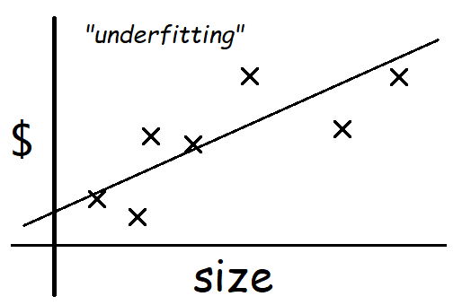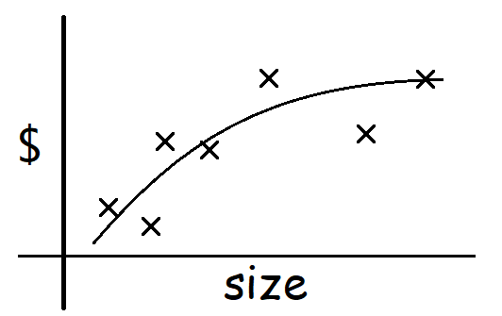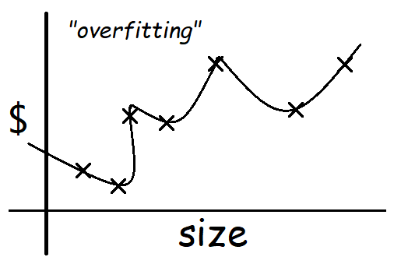

$θ_{0}+θ_{1}x_{1}$ $θ_{0}+θ_{1}x_{1}+θ_{2}x_{1}^{2}$ $θ_{0}+θ_{1}x_{1}+⋯+θ_{6}x_{1}^{6}$

”Parametric” learning algorithm: training examples - get $θ$ s - fixed set of parameters

🡪”Non-parametric” learning algorithm:

$$\left(definition\right)-number of parameters grows linearly with M\left(M is \#sets\right)$$

In another word, parameters rely the whole training sets, even after learning.

🡪 *locally weighted regression*(loess/lowess)

e.g.

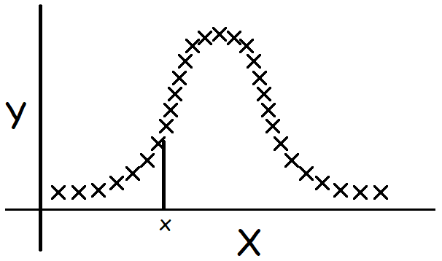

$$To evaluate h at a certain x$$

$$LR: Fit θ to minimize \sum_{i}{{\left(y^{\left(i\right)}-θ^{T}x^{\left(i\right)}\right)}^{2}}, then return θ^{T}x\left(the estimated h\right).$$

$$LWR: Fit θ to minimize$$

$$\sum_{i}{ω^{\left(i\right)}{\left(y^{\left(i\right)}-θ^{T}x^{\left(i\right)}\right)}^{2}}$$

$$where$$

$ω^{\left(i\right)}=e^{-\frac{{\left(x^{\left(i\right)}-x\right)}^{2}}{2τ^{2}}}$ $\left(ω^{\left(i\right)}∈\left(0,1\right) τ is called "bandwith"\right)$

$If \left|x^{\left(i\right)}-x\right| smail, then ω^{\left(i\right)}≈1$ $If \left|x^{\left(i\right)}-x\right| large, then ω^{\left(i\right)}≈0$

② Probabilistic interpretation

🡪

PS: $P\left(y^{\left(i\right)}|x^{\left(i\right)},θ\right)$ means the probability of $y^{\left(i\right)}$ given $x^{\left(i\right)},θ$ (independent variables);

$P\left(y^{\left(i\right)}|x^{\left(i\right)};θ\right)$ means the probability of $y^{\left(i\right)}$ given $x^{\left(i\right)}$ and parameterized by

**🡪** :

③ Logistic regression (Classification)

🡪

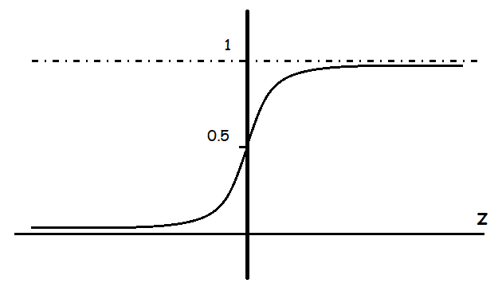

🡪 ,

🡪

🡪

perceptron algorithm

$$Choose cost function:$$

$$h_{θ}\left(x\right)=g\left(θ^{T}x\right)=\left\{\begin{aligned}1 if θ^{T}x≥0 \\ 0 otherwise\end{aligned}\right.$$

$$repeat till convergence:$$

$$θ_{j}∶=θ_{j}+α·\left(y^{\left(i\right)}-h_{θ}\left(x^{\left(i\right)}\right)\right)·x_{j}^{\left(i\right)}$$

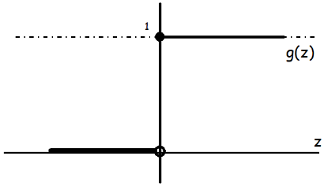

**Lesson 4**

① Logistic regression – Newton’s Method

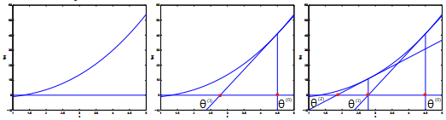

🡪

② Exponential Family

🡪

🡪

🡪

③ Generalized Linear Models (GLMs)

🡪

🡪

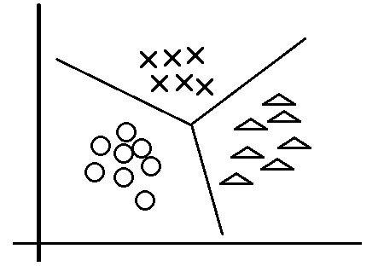🡪

🡪

Softmax regression:

🡪

🡪

**Lesson 5**

*Outline this Lesson:*

1. Generative learning algorithms

2. GDA (Gaussian discriminant analysis)🡪digression: Gaussians

3. Generative & Discriminative comparison (GDA & logistic regression comparison)

4. Naive Bayes

5. Laplace Smoothing

① generative learning algorithms (e.g. logistic regression)

🡪

-

-

🡪

-

② GDA (Gaussian Discriminant Analysis)

$assume$ $x∈R^{n},continuous\text{-}valued$ $p\left(x | y\right) is Gaussian$

$x \sim N\left(\overset{⃑}{μ},Σ\right)$ $where \overset{⃑}{μ} is the mean of x, Σ \left(∈R^{n×n}\right) is the covariance matrix$

$$p\left(x\right)=\frac{1}{{\left(2π\right)}^{n/2}{\left|Σ\right|}^{1/2 }}e^{-\frac{1}{2}{\left(x-μ\right)}^{T}Σ^{-1}\left(x-μ\right)}$$

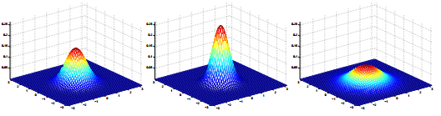

$Σ=\left[\begin{matrix}1 & 0 \\ 0 & 1\end{matrix}\right];$ $Σ=\left[\begin{matrix}0.6 & 0 \\ 0 & 0.6\end{matrix}\right];$ $Σ=\left[\begin{matrix}2 & 0 \\ 0 & 2\end{matrix}\right]$

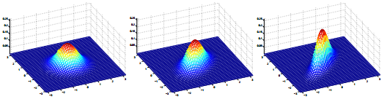 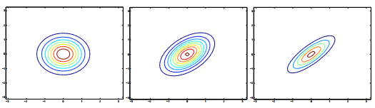

$Σ=\left[\begin{matrix}1 & 0 \\ 0 & 1\end{matrix}\right];$ $Σ=\left[\begin{matrix}1 & 0.5 \\ 0.5 & 1\end{matrix}\right];$ $Σ=\left[\begin{matrix}1 & 0.8 \\ 0.8 & 1\end{matrix}\right]$

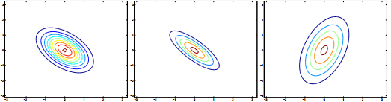

$Σ=\left[\begin{matrix}1 & -0.5 \\ -0.5 & 1\end{matrix}\right];$ $Σ=\left[\begin{matrix}1 & -0.8 \\ -0.8 & 1\end{matrix}\right];$ $Σ=\left[\begin{matrix}3 & 0.8 \\ 0.8 & 1\end{matrix}\right]$

figure: different covariance of Gaussian functions (2-D)

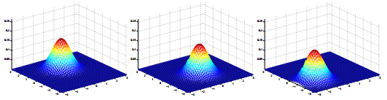

$μ=\left[\begin{matrix}1 \\ 0\end{matrix}\right];$ $μ=\left[\begin{matrix}-0.5 \\ 0\end{matrix}\right];$ $μ=\left[\begin{matrix}-1 \\ -1.5\end{matrix}\right]$

figure: different means of Gaussian functions (2-D)

🡪

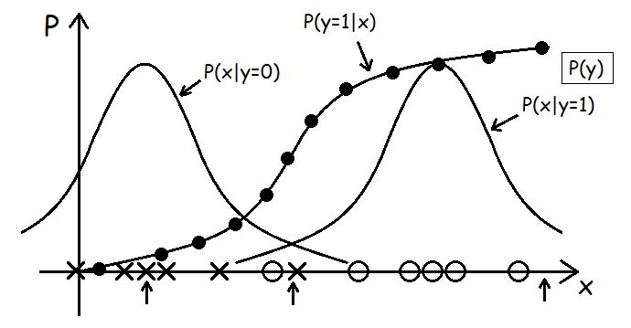

③ GDA & logistic regression comparison

$$\begin{matrix}x|y \sim Gaussian \\ ⇓ ⇑ \\ logistic posterior for p\left(y=1 | x\right)\end{matrix}$$

$$accordingly,$$

$$\left\{\begin{matrix}\begin{aligned}x|y=1 \sim Poisson\left(λ_{1}\right) \\ x|y=0 \sim Poisson\left(λ_{0}\right)\end{aligned} & \begin{matrix}⇒ \\ ⇍\end{matrix}\end{matrix}\right. p\left(y=1 | x\right) is logistic$$

$$more generally,$$

$$\left\{\begin{matrix}\begin{aligned}x|y=1 \sim ExpFamily\left(η_{1}\right) \\ x|y=0 \sim ExpFamily\left(η_{0}\right)\end{aligned} & \begin{matrix}⇒ \\ ⇍\end{matrix}\end{matrix}\right. p\left(y=1 | x\right) is logistic$$

It shows that logistic regression is robust for different classification questions.

GDA makes stronger modeling assumptions, and is more data efficient (i.e., requires less training data to learn “well”) when the modeling assumptions are (approximately) correct.

Logistic regression makes weaker assumptions, and is significantly more robust to deviations from modeling assumptions.

④ Naive Bayes (e.g. text classification: anti-spam)

$y∈\left\{0,1\right\}$ $\left(1 represent spam email\right)$

$$x=\begin{matrix}\left[ \begin{matrix}\begin{matrix}\begin{matrix}1 \\ 0 \\ ⋮\end{matrix} \\ 1 \\ 0\end{matrix} \\ ⋮ \\ 0\end{matrix} \right] & \left.\begin{matrix}\begin{matrix}\begin{matrix}a \\ aardvark \\ ⋮\end{matrix} \\ buy \\ cs229\end{matrix} \\ ⋮ \\ zygmurgy\end{matrix} \right| \begin{matrix}\begin{matrix}p\left(x | y\right) \\ x∈{\left\{0,1\right\}}^{n} \\ n=50,000\end{matrix} \\ 2^{50,000} results \\ 2^{50,000}-1 parameters\end{matrix}\end{matrix}$$

$$assume x_{i}^{'}s are conditinally independent given y$$

$$p\left(x_{1},…,x_{50000} | y\right)$$

$$=p\left(x_{1} | y\right)p\left(x_{2} | y,x_{1}\right)p\left(x_{3} | y,x_{1},x_{2}\right)⋯p\left(x_{50000} | y,x_{1},…,x_{49999}\right)$$

$=p\left(x_{1} | y\right)p\left(x_{2} | y\right)p\left(x_{3} | y\right)⋯p\left(x_{50000} | y\right)$ $\left(conditinally independent\right)$

$$=\prod_{i=1}^{n}{p\left(x_{i} | y\right)}$$

$$Parameterize:$$

$$\begin{matrix}\begin{matrix}\begin{matrix}ϕ_{i|y=1}=p\left(x_{i}=1 | y=1\right) \\ ϕ_{i|y=0}=p\left(x_{i}=1 | y=0\right) \\ ϕ_{y}=p\left(y=1\right)\end{matrix} & \begin{matrix}→ \\ \begin{matrix}↗ \\ →\end{matrix}\end{matrix}\end{matrix} & \begin{matrix}build p\left(x | y\right) \\ build p\left(y\right)\end{matrix}\end{matrix}$$

$∴Joint likelihood:$

$$L\left(ϕ_{y},ϕ_{j|y=0},ϕ_{j|y=1}\right)=\prod_{i=1}^{m}{p\left(x^{\left(i\right)},y^{\left(i\right)}\right)}$$

$ϕ_{j|y=1}=\frac{\sum_{i=1}^{m}{1\left\{x_{j}^{\left(i\right)}=1,y^{\left(i\right)}=1\right\}}}{\sum_{i=1}^{m}{1\left\{y^{\left(i\right)}=1\right\}}}$

$ϕ_{j|y=0}=\frac{\sum_{i=1}^{m}{1\left\{x_{j}^{\left(i\right)}=1,y^{\left(i\right)}=0\right\}}}{\sum_{i=1}^{m}{1\left\{y^{\left(i\right)}=0\right\}}}$

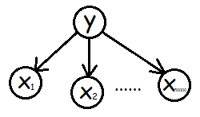 $ϕ_{y}=\frac{\sum_{i=1}^{m}{1\left\{y^{\left(i\right)}=1\right\}}}{m}$

$$∴When predict a new sample:$$

$$P\left(y=1 | x\right)=\frac{P\left(x | y=1\right)p\left(y=1\right)}{p\left(x\right)}$$

$$=\frac{\left(\prod_{i=1}^{n}{p\left(x_{i} | y=1\right)}\right)p\left(y=1\right)}{\left(\prod_{i=1}^{n}{p\left(x_{i} | y=1\right)}\right)p\left(y=1\right)+\left(\prod_{i=1}^{n}{p\left(x_{i} | y=0\right)}\right)p\left(y=0\right)}$$

⑤ Laplace Smoothing

When a brand new word (e.g. “NIPS”, which is the 30,000th word in dictionary) inputs, the prior probabilities are as follows:

$$P\left(x_{30000}=1 | y=1\right)=0$$

$$P\left(x_{30000}=1 | y=0\right)=0$$

$$and then,$$

$$P\left(y=1 | x\right)=\frac{\left(\prod_{i=1}^{n}{p\left(x_{i} | y=1\right)}\right)p\left(y=1\right)}{\left(\prod_{i=1}^{n}{p\left(x_{i} | y=1\right)}\right)p\left(y=1\right)+\left(\prod_{i=1}^{n}{p\left(x_{i} | y=0\right)}\right)p\left(y=0\right)}=\frac{0}{0}$$

To avoid this problem, we use Laplace Smoothing to replace estimate with

$$P\left(y=j\right)=ϕ_{j}=\frac{\sum_{i=1}^{m}{1\left\{y^{\left(i\right)}=j\right\}}+1}{m+k}$$

$$\left(k is \#class, the all y^{'}s possible values\right)$$

**Lesson 6**

*Outline this Lesson:*

1. Naive Bayes – event models

2. Neural Networks (Intro.)

3. Support Vector Machines

① event models

$$primal$$

$x=\begin{matrix}\left[ \begin{matrix}\begin{matrix}\begin{matrix}1 \\ 0 \\ 0\end{matrix} \\ ⋮ \\ 1\end{matrix} \\ 0\end{matrix} \right]\end{matrix} x_{i}∈\left\{0,1\right\}$ $\begin{matrix}\begin{matrix}Generative Learning algorithm: \\ 1. P\left(x | y\right)=\prod_{i=1}^{n}{P\left(x_{i} | y\right)} \\ 2. P\left(y\right)\end{matrix} \\ 3.\arg{\max_{y}{P\left(y | x\right)}}=\arg{\max_{y}{P\left(x | y\right)P\left(y\right)}} \\ n=\# words in dictionary\left(e.g. 50,000\right)\end{matrix}$

called *“Multi-variate Bernoulli* *event model”*

(here $x$ represents one of samples, $x_{i}$ is one of words in dictionary whether in $x$ or not)

*without using number information?* 🡪

*Multinomial event model*

$$P\left(x | y\right)=\prod_{i=1}^{n}{P\left(x_{i} | y\right)} here x_{i} is multinomial$$

e.g.



back to primal example, we can change the model with

$x^{\left(i\right)}=\left(x_{1}^{\left(i\right)},x_{2}^{\left(i\right)},…,x_{n_{i}}^{\left(i\right)}\right)$ $n_{i}=\# words in email x^{\left(i\right)}, x_{j}^{\left(i\right)}∈\left\{1,2,…,50000\right\}$

($x^{\left(i\right)}$ is a vector with different length in emails, $x_{i}$ represents the number where in dictionary)

🡪

Because Naive Bayes algorithm is built by Bernoulli or Multinomial (i.e. or other distributions), it still belongs to exponential family (GLMs), so finally, it is still a *linear classifier*.

② Neural Networks

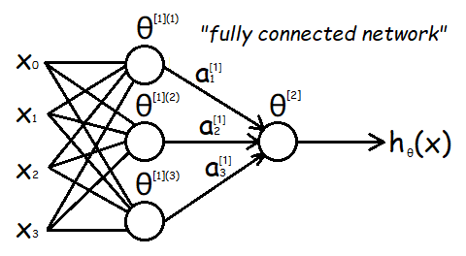

$$x=\left[\begin{matrix}x_{0} \\ \begin{matrix}x_{1} \\ x_{2} \\ x_{3}\end{matrix}\end{matrix}\right] {\overset{⃑}{a}}^{\left[2\right]}=\left[\begin{matrix}\begin{matrix}a_{1}^{\left[1\right]} \\ a_{2}^{\left[1\right]} \\ a_{3}^{\left[1\right]}\end{matrix}\end{matrix}\right]$$

$$\begin{matrix}\begin{matrix} g\left(z\right) =\frac{1}{1+e^{-z}}(or others, nonlinear) \\ a_{i}^{\left[1\right]} =g\left(x^{T}θ^{\left[1\right]\left(i\right)}\right) i=1,…,3 \\ h_{θ}\left(x\right)=g\left({\overset{⃑}{a}}^{\left[2\right]T}θ^{\left[2\right]}\right)\end{matrix} \\ J\left(θ\right)=\frac{1}{2}\sum_{i=1}^{m}{{\left(y^{\left(i\right)}-h_{θ}\left(x^{\left(i\right)}\right)\right)}^{2}}\end{matrix}$$

*Q: How to build a basic neural network and compute all the parameters?*

*- references: cs229-notes-deep_learning & cs229-notes-backprop*

③ Support Vector Machines

(1) Functional margins (e.g. logistic regression)

$$\begin{matrix}\begin{matrix}\begin{matrix}Compute θ^{T}x \\ Predicts "1" ⇔ θ^{T}x≥0 \\ Predicts "0" ⇔ θ^{T}x<0\end{matrix} \\ If θ^{T}x≫0, very "confident" that y=1 \\ If θ^{T}x≪0, very "confident" that y=0\end{matrix} \\ Nice if ∀i s.t. y^{\left(i\right)}=1, have θ^{T}x^{\left(i\right)}≫0 \\ ∀i s.t. y^{\left(i\right)}=0, have θ^{T}x^{\left(i\right)}≪0\end{matrix}$$

(2) Geometric margins

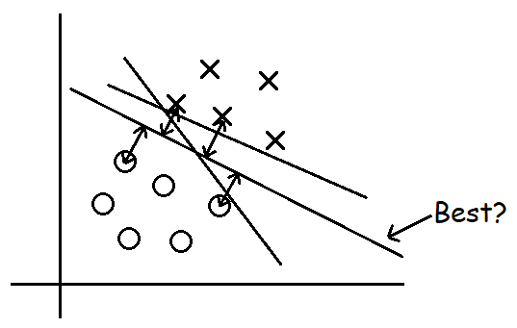

(3) notation

$$y∈\left\{-1,+1\right\} g\left(z\right)=\left\{\begin{aligned}1 if z≥0 \\ -1 otherwise\end{aligned}\right.$$

$$have (function) h output values in \left\{-1,+1\right\}$$

$$\begin{matrix} h_{θ}\left(x\right) =g\left(θ^{T}x\right) (x_{0}=1) x∈R^{n+1} \\ ↓ \\ h_{w,b}\left(x\right)=g\left(w^{T}x+b\right) where w={(θ_{1},…,θ_{n})}^{T}, b=θ_{0} \end{matrix}$$

(4) definition & deduction

🡪

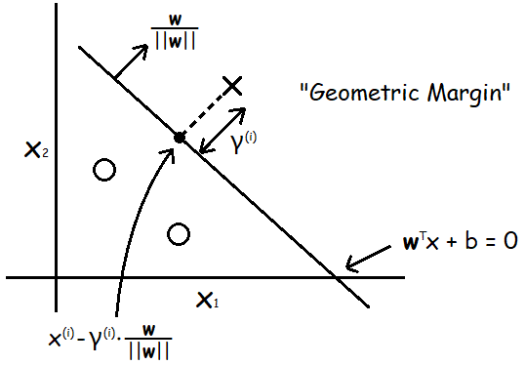

🡪

So to the whole samples, we have the definition of “geometric margin” as follows:

$$Geometric margin:$$

$$γ=\min_{i}{γ^{\left(i\right)}}$$

$$Max margin classifier:$$

$$\max_{γ,w,b}{γ}$$

$$s.t. y^{\left(i\right)}\left(w^{T}x^{\left(i\right)}+b\right)≥γ i=1,…,m$$

$$\left\|w\right\|=1$$

**Lesson 7**

*Outline this Lesson:*

1. Optimal Margin Classifier

2. Primal/Dual Optimization problem (KKT)

3. SVM dual

4. Kernels

① Optimal margin classifier

from last lesson, we know that change the constraints like:

$$\left\|w\right\|=1, \left|w_{1}\right|=1, w_{1}^{2}+\left|w_{1}\right|=1,…$$

will not change the original optimization problem. so,

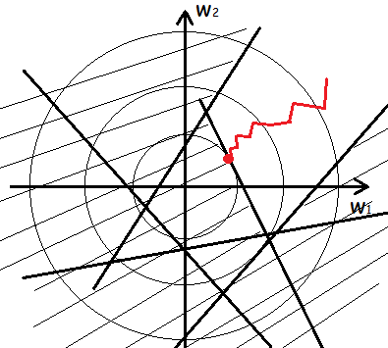🡪

so, original problem can re-describe into:

$$\#3$$

$$\min_{w,b}{{\left\|w\right\|}^{2}}$$

$$s.t. y^{\left(i\right)}\left(w^{T}x^{\left(i\right)}+b\right)≥1 i=1,…,m$$

② Primal/Dual Optimization problem

here's a function of $w, f\left(w\right),$ that

$$\min_{w}{f\left(w\right)}$$

$$\begin{matrix}s.t. h_{i}\left(w\right)=0 i=1,…,l & or "h\left(w\right)=\left[\begin{matrix}\begin{matrix}h_{1}\left(w\right) \\ h_{2}\left(w\right)\end{matrix} \\ ⋮ \\ h_{l}\left(w\right)\end{matrix}\right]=\overset{⃑}{0}"\end{matrix}$$

we can build a *“Lagrange equation”* to re-describe it as:

🡪

- *why?*

🡪

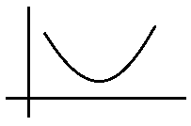

③ SVM dual (& KKT conditions)

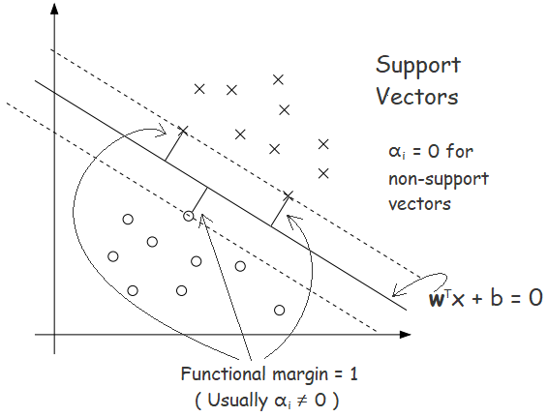

SVM cost function as:

$$J\left(w,b\right)=\min_{w,b}{\frac{1}{2}{\left\|w\right\|}^{2}}$$

$$s.t. y_{i}\left(w^{T}x_{i}+b\right)≥1 \left(i=1,…,m\right)$$

Lagrange duality

$$primal equation$$

$$\max_{α_{i}≥0}{L\left(w,b,α\right)}=\max_{α_{i}≥0}\left(\frac{1}{2}{\left\|w\right\|}^{2}-\sum_{i=1}^{m}{α_{i}·\left[y^{\left(i\right)}\left(w^{T}x^{\left(i\right)}+b\right)-1\right]}\right)$$

$$p^{*}=\min_{w,b}{\max_{α_{i}≥0}{L\left(w,b,α\right)}}$$

$$duality equation$$

$$d^{*}=\max_{α_{i}≥0}{\min_{w,b}{L\left(w,b,α\right)}}$$

$$KKT conditions\left(make p^{*}=d^{*}=L\left(w^{*},α^{*},β^{*}\right)\right):$$

$\frac{∂}{∂w_{i}}L\left(w^{*},α^{*},β^{*}\right)=0, i=1,…, n$ $\left(1\right)$

$\frac{∂}{∂β_{i}}L\left(w^{*},α^{*},β^{*}\right)=0, i=1,…, l$ $\left(2\right)$

${ α}_{i}^{*}g_{i}\left(w^{*}\right)=0, i=1,…, k$ $\left(KKT complementary condition\right)$ $\left(3\right)$

$g_{i}\left(w^{*}\right)≤0, i=1,…, k$ $\left(4\right)$

$α_{i}^{*}≥0, i=1,…, k$ $\left(5\right)$

$$L\left(w,b,α\right)=\frac{1}{2}{\left\|w\right\|}^{2}-\sum_{i=1}^{m}{α_{i}·\left[y^{\left(i\right)}\left(w^{T}x^{\left(i\right)}+b\right)-1\right]} \left(6\right)$$

$$Dual problem:$$

$$θ_{D}\left(α\right)=\min_{w,b}{L\left(w,b,α\right)}$$

$$by KKT condition \left(1\right)\left(2\right):$$

$$∇_{w}L\left(w,b,α\right)=w-\sum_{i=1}^{m}{α_{i}y^{\left(i\right)}x^{\left(i\right)}}\underset{→}{set}0$$

$$w=\sum_{i=1}^{m}{α_{i}y^{\left(i\right)}x^{\left(i\right)}} \left(7\right)$$

$$\frac{∂}{∂b}L\left(w,b,α\right)=-\sum_{i=1}^{m}{α_{i}y^{\left(i\right)}}\underset{→}{set}0 \left(8\right)$$

$$from Equation \left(6\right)\left(7\right)\left(8\right):$$

$$L\left(w,b,α\right)=\sum_{i=1}^{m}{α_{i}}-\frac{1}{2}\sum_{i=1}^{m}{\sum_{j=1}^{m}{y^{\left(i\right)}y^{\left(j\right)}α_{i}α_{j}{\left(x^{\left(i\right)}\right)}^{T}x^{\left(j\right)}}}$$

$$W\left(α\right)=\sum_{i=1}^{m}{α_{i}}-\frac{1}{2}\sum_{i=1}^{m}{\sum_{j=1}^{m}{y^{\left(i\right)}y^{\left(j\right)}α_{i}α_{j}〈x^{\left(i\right)},x^{\left(j\right)}〉}}$$

From above, we know that $L\left(w,b,α\right)$ just associate with $α$**.** So,

$$Dual problem:$$

$$\max_{α}{W\left(α\right)}$$

$$\begin{matrix}s.t. α_{i}≥0 \left(i=1,…,m\right) \\ \sum_{i=1}^{m}{α_{i}y^{\left(i\right)}}=0\end{matrix}$$

Once we solve the dual problem, we can easily solve for $w,b$:

$$Solve for α, then$$

$$w^{*}=\sum_{i=1}^{m}{α_{i}y^{\left(i\right)}x^{\left(i\right)}}$$

$$b^{*}=-\frac{1}{2}\left(\max_{i:y^{\left(i\right)}=-1}{{w^{*}}^{T}x^{\left(i\right)}}+\min_{i:y^{\left(i\right)}=1}{{w^{*}}^{T}x^{\left(i\right)}}\right)$$

$$(α_{i}≠0 only for support vectors!!!)$$

*Finally, to predict new sample(s), we just need calculate:

$$y^{p}=\left\{\begin{aligned}\begin{matrix}\begin{matrix} +1 \\ -1\end{matrix} & \begin{matrix}if {w^{*}}^{T}x^{p}+b^{*}≥0 \\ otherwise\end{matrix}\end{matrix}\end{aligned}\right.$$

④ Kernels

$$w=\sum_{i=1}^{m}{α_{i}y^{\left(i\right)}x^{\left(i\right)}}$$

$$w^{T}x+b={\left(\sum_{i=1}^{m}{α_{i}y^{\left(i\right)}x^{\left(i\right)}}\right)}^{T}x+b$$

$$=\sum_{i=1}^{m}{α_{i}y^{\left(i\right)}〈x^{\left(i\right)},x〉}+b$$

$Assume$ $h_{w,b}\left(x\right)=g\left(w^{T}x+b\right)$

$then h can be describe by those inner products$ $〈x^{\left(i\right)},x^{\left(j\right)}〉.$

$If$ $x^{\left(i\right)} belongs to very high dimension$ $(e.g.$ $x^{\left(i\right)}∈R^{∞}$ $), h almost can't$

$be computed easily. However, if h can be transfered like$ $〈x^{\left(i\right)},x^{\left(j\right)}〉, it can be$

$$computed very efficiently.(not only in SVM algorithm !‼)$$

$$Kernel:$$

$$K\left(x,z\right)={ϕ\left(x\right)}^{T}ϕ\left(z\right)$$

*\*Lagrange duality problem must be a convex optimization problem!*

proof as follows:

(<https://www.cnblogs.com/xubing-613/p/5941549.html> )

**Lesson 8**

*Outline this Lesson:*

1. Kernels

2. Soft margin

3. SMO algorithm

① Kernels

$$K\left(x,z\right)={ϕ\left(x\right)}^{T}ϕ\left(z\right)$$

e.g. $Have x∈R (x is living area)$

$$x\underset{→}{ϕ}\left[\begin{matrix}x \\ \begin{matrix}x^{2} \\ x^{3}\end{matrix}\end{matrix}\right]=ϕ\left(x\right)$$

$Replace$ $〈x^{\left(i\right)},x^{\left(j\right)}〉$ $with$ $〈ϕ\left(x^{\left(i\right)}\right),ϕ\left(x^{\left(j\right)}\right)〉$ $(ϕ\left(x\right) \text{-} can be very high dim.)$

$$K\left(x^{\left(i\right)},x^{\left(j\right)}\right)=〈ϕ\left(x^{\left(i\right)}\right),ϕ\left(x^{\left(j\right)}\right)〉$$

e.g. 2 $(here n=3)$

$$x,z∈R^{n}, K\left(x,z\right)={\left(x^{T}z\right)}^{2}$$

$$K\left(x,z\right)=\left(\sum_{i=1}^{n}{x_{i}z_{i}}\right)\left(\sum_{j=1}^{n}{x_{j}z_{j}}\right)=\sum_{i=1}^{n}{\sum_{j=1}^{n}{\left(x_{i}x_{j}\right)\left(z_{i}z_{j}\right)}}={\left(ϕ\left(x\right)\right)}^{T}\left(ϕ\left(z\right)\right)$$

$$ϕ\left(x\right)=\begin{matrix}\left[ \begin{matrix}\begin{matrix}\begin{matrix}x_{1}x_{1} \\ x_{1}x_{2} \\ x_{1}x_{3}\end{matrix} \\ \begin{matrix}x_{2}x_{1} \\ x_{2}x_{2} \\ x_{2}x_{3}\end{matrix} \\ \begin{matrix}x_{3}x_{1} \\ x_{3}x_{2} \\ x_{3}x_{3}\end{matrix}\end{matrix}\end{matrix} \right] & \begin{matrix}Need O\left(n^{2}\right) time to compute ϕ\left(x\right) \\ Only need O\left(n\right) time to compute K\left(x,z\right)\end{matrix}\end{matrix}$$

e.g. 3 $(here n=3)$

$$K\left(x,z\right)={\left(x^{T}z+c\right)}^{2}$$

$$ϕ\left(x\right)=\left[ \begin{matrix}\begin{matrix}\begin{matrix}x_{1}x_{1} \\ x_{2}x_{2} \\ x_{3}x_{3}\end{matrix} \\ \begin{matrix}\sqrt{2}x_{1}x_{2} \\ \sqrt{2}x_{1}x_{3} \\ \sqrt{2}x_{2}x_{3}\end{matrix} \\ \begin{matrix}\sqrt{2c}x_{1} \\ \sqrt{2c}x_{2} \\ \sqrt{2c}x_{3} \\ c\end{matrix}\end{matrix}\end{matrix} \right]$$

e.g. 4 (polynomial kernel)

$K\left(x,z\right)={\left(x^{T}z+c\right)}^{d}$ $↦\left(\begin{aligned}n+d \\ d\end{aligned}\right) \begin{matrix}\begin{matrix}features of all monomials \\ up to degree "d"(d≤n)\end{matrix}\end{matrix}$

e.g. 5 (Gaussian kernel/radial basis function)

$$x↦ϕ\left(x\right), z↦ϕ\left(z\right)$$

$$〈ϕ\left(x\right),ϕ\left(z\right)〉 \left| \begin{matrix}large if x,z similar \\ small if x,z "dissimilar"\end{matrix}\right.$$

$$K\left(x,z\right)=e^{-\frac{{\left\|x-z\right\|}^{2}}{2σ^{2}}} or e^{-γ{\left\|x-z\right\|}^{2}}(γ>0)$$

*- $∃ϕ st. K\left(x,z\right)=〈ϕ\left(x\right),ϕ\left(z\right)〉$?*

$Suppose K is a kernel. Let$ $\left\{x^{\left(1\right)},…,x^{\left(m\right)}\right\} be given,$ $let K∈R^{m×m}$

$$K_{ij}=K\left(x^{\left(i\right)},x^{\left(j\right)}\right)$$

$Then, for ∀ vector z∈R^{m} (a^{T}b=\sum_{k}{a_{k}b_{k}})$

$$z^{T}Kz=\sum_{i}{\sum_{j}{z_{i}K_{ij}z_{j}}}$$

$$=\sum_{i}{\sum_{j}{z_{i}{ϕ\left(x^{\left(i\right)}\right)}^{T}ϕ\left(x^{\left(j\right)}\right)z_{j}}}$$

$$=\sum_{i}{\sum_{j}{z_{i}\sum_{k}{ϕ_{k}\left(x^{\left(i\right)}\right)ϕ_{k}\left(x^{\left(j\right)}\right)}z_{j}}}$$

$$=\sum_{k}{\sum_{i}{\sum_{j}{z_{i}ϕ_{k}\left(x^{\left(i\right)}\right)ϕ_{k}\left(x^{\left(j\right)}\right)z_{j}}}}$$

$$=\sum_{k}{{\left(\sum_{i}{z_{i}ϕ_{k}\left(x^{\left(i\right)}\right)}\right)}^{2}}$$

$$≥0$$

$$Mercer Theorem:$$

$Let$ $K\left(x,z\right)$ $be given. Then K is a valid \left(Mercer\right) kernel (i.e. ∃ϕ st. K\left(x,z\right)=$

${ϕ\left(x\right)}^{T}ϕ\left(z\right)) if and only if for all$ $\left\{x^{\left(1\right)},…,x^{\left(m\right)}\right\}\left(m<∞\right)$ $the kernel matrix$

$$K∈R^{m×m} is symmetric positive semi\text{-}definite.$$

e.g. $K\left(x,x\right)=-1≠{ϕ\left(x\right)}^{T}ϕ\left(x\right)$

*- How to use kernels?*

$$Choose K\left(x,z\right)=x^{T}z+b or {\left(x^{T}z+c\right)}^{d} or e^{-\frac{{\left\|x-z\right\|}^{2}}{2σ^{2}}} or…$$

$$Replace 〈x^{\left(i\right)},x^{\left(j\right)}〉 with K\left(x^{\left(i\right)},x^{\left(j\right)}\right)$$

$("hiddenly" x^{\left(i\right)}→ϕ\left(x^{\left(i\right)}\right), rather than just in SVM!)$

$$Compute result$$

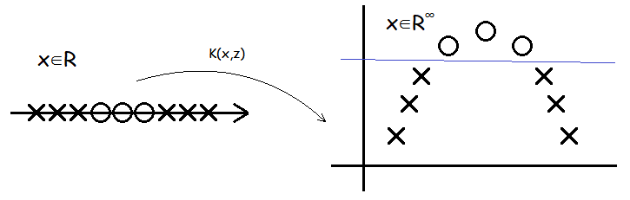

② Soft margin (Regularization)

“L1 (or L2) norm soft margin SVM”

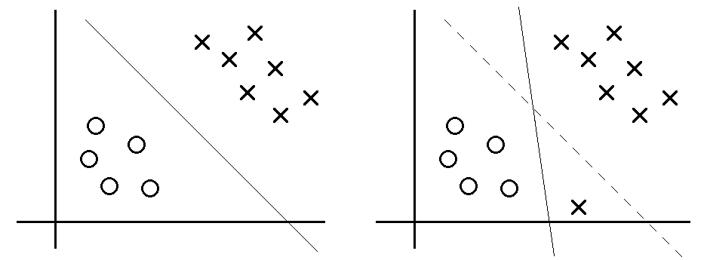

$$\min_{w,b,ξ}{\frac{1}{2}{\left\|w\right\|}^{2}+C\sum_{i=1}^{m}{ξ_{i}(or ξ_{i}^{2})}}$$

$$s.t. y_{i}\left(w^{T}x_{i}+b\right)≥1-ξ_{i}$$

$$ξ_{i}≥0 \left(i=1,…,m\right)$$

$$L\left(w,b,ξ,α,r\right)=\frac{1}{2}{\left\|w\right\|}^{2}+C\sum_{i=1}^{m}{ξ_{i}}f\left(w\right)-\sum_{i=1}^{m}{α_{i}\left[y_{i}\left(w^{T}x_{i}+b\right)-1+ξ_{i}\right]}-\sum_{i=1}^{m}{r_{j}ξ_{j}}$$

$$Accordingly, we obtain the dual problem:$$

$$\max_{α}{W\left(α\right)=\sum_{i=1}^{m}{α_{i}}-\frac{1}{2}\sum_{i=1}^{m}{\sum_{j=1}^{m}{y^{\left(i\right)}y^{\left(j\right)}α_{i}α_{j}〈x^{\left(i\right)},x^{\left(j\right)}〉}}}$$

$$\begin{matrix}s.t. 0≤α_{i}≤C \left(i=1,…,m\right) \\ \sum_{i=1}^{m}{α_{i}y^{\left(i\right)}}=0\end{matrix}$$

$$\begin{matrix}\begin{matrix}α_{i}=0 \\ α_{i}=C \\ 0<α_{i}<C\end{matrix} & \begin{matrix}⇒ \\ ⇒ \\ ⇒\end{matrix} & \begin{matrix}y^{\left(i\right)}\left(w^{T}x^{\left(i\right)}+b\right)≥1 \\ y^{\left(i\right)}\left(w^{T}x^{\left(i\right)}+b\right)≤1 \\ y^{\left(i\right)}\left(w^{T}x^{\left(i\right)}+b\right)=1\end{matrix}\end{matrix}$$

③ SMO algorithm

- Digression: Coordinate ascent

Considering an unconstrained optimization problem:

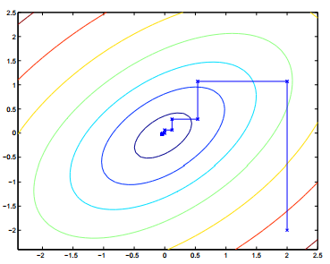

- Sequential Minimal Optimization (SMO)

$$\sum_{i=1}^{m}{α_{i}y^{\left(i\right)}}=0 ⇒ at least change 2 α_{i}^{'}s at a time$$

$$algorithm outline:$$

$1. Select α_{i},α_{j}$ $\left(\begin{aligned}heuristically use those can make the biggest \\ progress towards the global maximum\end{aligned}\right)$

$$2. Hold all α_{i}^{'}s fixed except α_{i},α_{j}$$

$$3. Reoptimize W\left(α\right) with respect to α_{i},α_{j}\left(s.t. constraints\right)$$

$$e.g.$$

$$Update α_{1},α_{2}. (Know \sum_{i=1}^{m}{α_{i}y^{\left(i\right)}}=0)$$

$$α_{1}y^{\left(1\right)}+α_{2}y^{\left(2\right)}=-\sum_{i=3}^{m}{α_{i}y^{\left(i\right)}}=ζ, 0≤α_{i}≤C$$

$$∵W\left(α_{1},α_{2},…,α_{m}\right)=\sum_{i=1}^{m}{α_{i}}-\frac{1}{2}\sum_{i=1}^{m}{\sum_{j=1}^{m}{y^{\left(i\right)}y^{\left(j\right)}α_{i}α_{j}〈x^{\left(i\right)},x^{\left(j\right)}〉}}$$

$$∴W\left(α_{1},α_{2},…,α_{m}\right)=W\left(\frac{ζ-α_{2}y^{\left(2\right)}}{y^{\left(1\right)}},α_{2},…,α_{m}\right)=Aα_{2}^{2}+Bα_{2}+C$$

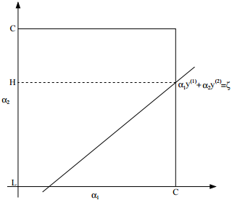

$$finally, original problem changes into:$$

$$\max_{α_{2}}{Aα_{2}^{2}+Bα_{2}+C}$$

$$s.t. L≤α_{2}≤H (in picture)$$

reference of how to choose $α_{i},α_{j}$& update $b$: *John Platt’s paper of SMO*

- two brief examples of using SVM

#1 Handler’s Integer Recognition

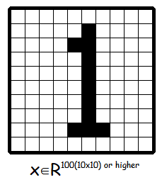

$$K\left(x,y\right)={\left(x^{T}y\right)}^{d} or\exp\left(-\frac{{\left\|x-y\right\|}^{2}}{2σ^{2}}\right)$$

$$In this case, using SVM with kernels like above, even much better than the best$$

$$Neural Network designed for many years!$$

#2 classify protein sequences

$represent amino acids by alphabet$*(even though only 20 to human’s protein XD)*

- *how to represent $ϕ\left(x\right)$?*

$$\begin{matrix}ϕ\left(x\right)∈R^{{20}^{4}} \\ →R^{160000} \\ DP: {ϕ\left(x\right)}^{T}ϕ\left(z\right)\end{matrix} \left| ϕ\left(x\right)=\begin{matrix}\left[ \begin{matrix}\begin{matrix}\begin{matrix}0 \\ ⋮ \\ 2\end{matrix} \\ ⋮ \\ 1\end{matrix} \\ ⋮ \\ 0\end{matrix} \right] & \begin{matrix}\begin{matrix}\begin{matrix}AAAA \\ ⋮ \\ BAJT\end{matrix} \\ ⋮ \\ IKAI\end{matrix} \\ ⋮ \\ ZZZZ\end{matrix}\end{matrix}\right.$$

**Lesson 9**

*Outline this Lesson:*

Learning Theory

1. Bias/Variance

2. Empirical Risk Minimization (ERM)

3. Union Bound & Hoeffding inequality

4. The case of finite $H$ (Uniform convergence)

① Bias/Variance

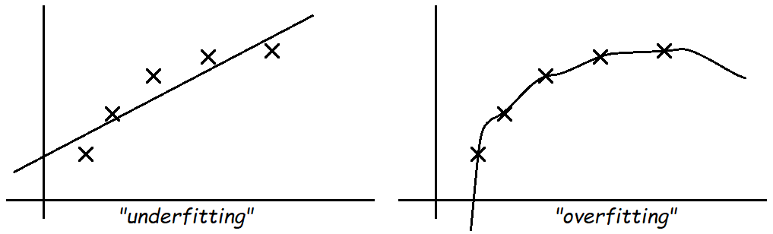 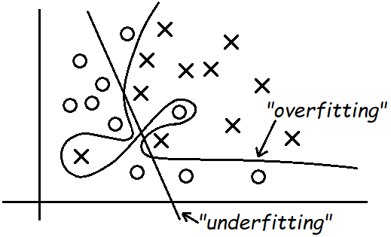

$\begin{matrix}θ_{0}+θ_{1}x \\ "bias"\end{matrix}$ $\begin{matrix}θ_{0}+θ_{1}x+⋯+θ_{4}x^{4} \\ "variance"\end{matrix}$ $h_{θ}\left(x\right)=g\left(\sum_{i=0}^{n}{θ_{i}x^{i}}\right)$

$$Linear\left(Binary\right) Classification:$$

$h_{θ}\left(x\right)=g\left(θ^{T}x\right), g\left(z\right)=1\left\{z≥0\right\}$ $here y∈\left\{0,1\right\}$

② Empirical Risk Minimization (ERM)

$$assume$$

$$S={\left\{\left(x^{\left(i\right)},y^{\left(i\right)}\right)\right\}}_{i=1}^{m}, \left(x^{\left(i\right)},y^{\left(i\right)}\right) \sim iidD$$

$$define$$

$$training error(empirical risk/error) of h_{θ}:$$

$$\hat{ε}\left(h_{θ}\right)={\hat{ε}}_{S}\left(h_{θ}\right)=\frac{1}{m}\sum_{i=1}^{m}{1\left\{h_{θ}\left(x^{\left(i\right)}\right)≠y^{\left(i\right)}\right\}}$$

$$ERM\left(empirical risk minimization\right):$$

$$\hat{θ}=\arg{\min_{θ}{\hat{ε}\left(h_{θ}\right)}}$$

$$more generally\left(in learning theory\right), assume$$

$$hypothesis function class H=\left\{h_{θ}·θ∈R^{n+1}\right\}$$

$ERM:$ $\hat{h}=\arg{\min_{h∈H}{\hat{ε}\left(h\right)}}$

All above is just curious about training with training sets, but our ultimate goal is the prediction, which means the accuracy of what we want to classify or seize. So we define

$$generalization error:$$

$$ε\left(h\right)=P_{\left(x,y\right)\sim D}\left(h\left(x\right)≠y\right)$$

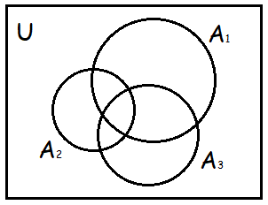③ Union Bound & Hoeffding inequality

$$\left(Union Bound\right)$$

$$Let A_{1},A_{2},…,A_{k} be k events\left(not necessarily independent\right). Then$$

$$P\left(A_{1}∪A_{2}∪⋯∪A_{k}\right)≤P\left(A_{1}\right)+P\left(A_{2}\right)+⋯+P\left(A_{k}\right)$$

$$e.g.$$

$$\begin{matrix}P\left(A_{1}∪A_{2}∪A_{3}\right)≤ \\ P\left(A_{1}\right)+P\left(A_{2}\right)+P\left(A_{3}\right)\end{matrix}$$

$$\left(Hoeffding inequality\right)$$

$$Let Z_{1},…,Z_{m} be m IID Bernoulli\left(ϕ\right) random variables\left(i.e. P\left(Z_{i}=1\right)=ϕ\right),$$

$\hat{ϕ}=\frac{1}{m}\sum_{i=1}^{m}{Z_{i}} , and let any γ>0 be fixed. Then$

$$P\left(\left|\hat{ϕ}-ϕ\right|>γ\right)≤2e^{-2γ^{2}m}$$

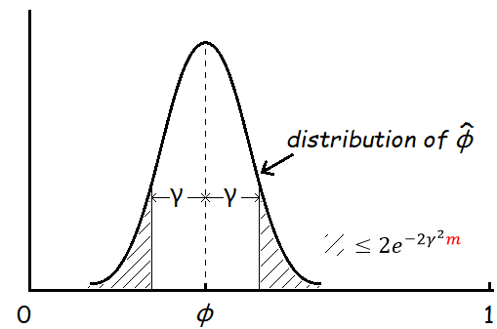

④ The case of finite $H$ (Uniform convergence)

$$H=\left\{h_{1},…,h_{k}\right\} k hypotheses \hat{h}=\arg{\min_{h_{i}∈H}{\hat{ε}\left(h_{i}\right)}}$$

$$\begin{matrix}Strategy of proof: \\ \begin{matrix}\left(1\right) \hat{ε}≈ε \\ \left(2\right) show upper\text{-}bound on ε\left(\hat{h}\right)\end{matrix}\end{matrix}$$

$assume$ $h_{j}∈H$

$define$ $Z_{i}=1\left\{h_{j}\left(x^{\left(i\right)}\right)≠y^{\left(i\right)}\right\}∈\left\{0,1\right\}$

$$∴ P\left(Z_{i}=1\right)=ε\left(h_{j}\right) Z_{i}s are IID (definition)$$

$$\hat{ε}\left(h_{j}\right)=\frac{1}{m}\sum_{i=1}^{m}{Z_{i}(mean ε(h_{j}))}=\frac{1}{m}\sum_{i=1}^{m}{1\left\{h_{j}\left(x^{\left(i\right)}\right)≠y^{\left(i\right)}\right\}}$$

$$let A_{j}=event that \left|ε\left(h_{j}\right)-\hat{ε}\left(h_{j}\right)\right|>γ, by Hoeffding inequality:$$

$$P\left(A_{j}\right)≤2e^{-2γ^{2}m}$$

$$P\left(∃h_{j}∈H, \left|ε\left(h_{j}\right)-\hat{ε}\left(h_{j}\right)\right|>γ\right) (just logistical meaning)$$

$$=P\left(A_{1}∪A_{2}∪⋯∪A_{k}\right)≤\sum_{i=1}^{k}{P\left(A_{i}\right)} (union bound)$$

$$≤\sum_{i=1}^{k}{2e^{-2γ^{2}m}}=2ke^{-2γ^{2}m} (Hoeffding inequality)$$

$$in the other words,$$

$$P\left(∀h_{j}∈H, \left|ε\left(h_{j}\right)-\hat{ε}\left(h_{j}\right)\right|≤γ\right)≥1-2ke^{-2γ^{2}m}$$

So we have the *uniform convergence*:

$$with probability (at least) 1-2ke^{-2γ^{2}m}, \hat{ε}(h) will be within γ$$

$$of ε(h) for all h∈H$$

From above, we can know that there are 3 quantities of interest: #samples $m$, bound $γ$ and the probability of error. Here’s some other ways to re-describe this solution where we can bound either one in terms of the other two!

(1) $Given γ, δ what is (the least) m?$

$$δ=2ke^{-2γ^{2}m}, solve for m?$$

Transform to solve m with this equation, we have the *sample complexity* bound:

$$So long as m≥\frac{1}{2γ^{2}}\log{\frac{2k}{δ}}, then with probability 1-δ, we$$

$$have that ∀h∈H, \left|ε\left(h\right)-\hat{ε}\left(h\right)\right|≤γ.$$

In practical, almost for finite $H$’s length k in Computer Science, it has “ $∀k,\log{k}≤30$”, which means we don’t worry too much about $m$ of vary kinds of hypothesis functions.

(2) $Fixed δ, m solve for γ$

Similarly, we have the *error bound*:

$$With probability 1-δ, we have that ∀h∈H,$$

$$\left|ε\left(h\right)-\hat{ε}\left(h\right)\right|≤\sqrt{\frac{1}{2m}\log{\frac{2k}{δ}}}(γ)$$

$assume$ $\left|ε\left(h\right)-\hat{ε}\left(h\right)\right|≤γ$ $\left(1\right)$

$let$ $\hat{h}=\arg{\min_{h∈H}{\hat{ε}\left(h\right)}},$ $\left(training error\right)$ $\left(2\right)$

$h^{*}=\arg{\min_{h∈H}{ε(h)}}$ $\left(generalization error\right)$ $\left(3\right)$

$ε\left(\hat{h}\right)≤\hat{ε}\left(\hat{h}\right)+γ$ $by \left(1\right)$

$≤\hat{ε}\left(h^{*}\right)+γ$ $by \left(2\right)$

$≤ε\left(h^{*}\right)+2γ$ $by \left(1\right)$

From above, we have proved a so-called *bias variance tradeoff* theorem:

$$Let \left|H\right|=k, and let any m,δ be fixed. Then w.p. (at least) 1-δ,$$

$$we have that$$

$ε\left(\hat{h}\right)≤\left(\min_{h∈H}{ε\left(h\right)}\right)+2\sqrt{\frac{1}{2m}\log{\frac{2k}{δ}}}$

$$ε\left(h^{*}\right) "bias" "variance"$$

E.g., we have some larger hypothesis class $H^{'}⊇H$, switching to $H^{'}$ means $\min_{h}{ε\left(h\right)}$

(bias) can only decrease, meanwhile, the $2\sqrt{·}$ term will increase (variance) by increasing k.

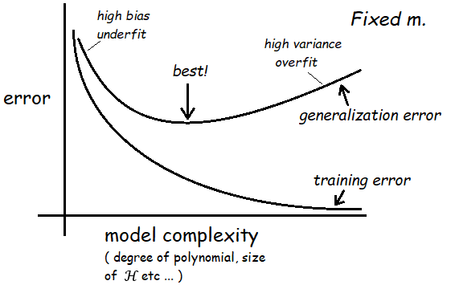

$$Corollary: Let \left|H\right|=k, and let any δ,γ be fixed. Then for$$

$$ε\left(\hat{h}\right)≤\min_{h∈H}{ε\left(h\right)}+2γ w.p. (at least) 1-δ, it suffices that$$

$$m≥\frac{1}{2γ^{2}}\log{\frac{2k}{δ}}$$

$$=O\left(\frac{1}{γ^{2}}\log{\frac{k}{δ}}\right)$$

PS: $m$ is the *size* of training set, $γ$ is the *gap* between training error & generalization error, $δ$ is the *probability* of this condition isn’t satisfied.

**Lesson 10**

*Outline this Lesson:*

Learning Theory

1. The case of infinite $H$ (VC dimension)🡪digression: tie up some loose facts

2. Model selection: Cross validation & Feature Selection

① The case of infinite $H$ (VC dimension)

$$assume H is parameterized by d real numbers$$

$$e.g. 64 d bits\left(in computer system\right)$$

$$∴k=\left|H\right|=2^{64d}, suffices that$$

$$m≥O\left(\frac{1}{γ^{2}}\log{\frac{2^{64d}}{δ}}\right)=O\left(\frac{d}{γ^{2}}\log{\frac{1}{δ}}\right)=O_{γ,δ}\left(d\right)$$

In this case, the number of training set almost linear with the parameter $d$, but not all the hypothesis class own this linear feature (generally, only suit for linear hypothesis).

$$assume$$

$Given a set$ $S=\left\{x^{\left(i\right)},…,x^{\left(d\right)}\right\}, x^{\left(i\right)}∈X$

$$define$$

$$H shatters S if H can realize any labelling on it.$$

$e.g.$ $H=\left\{linear classifiers in 2\text{-}D\right\}$ $(\left|S\right|=2,3)$

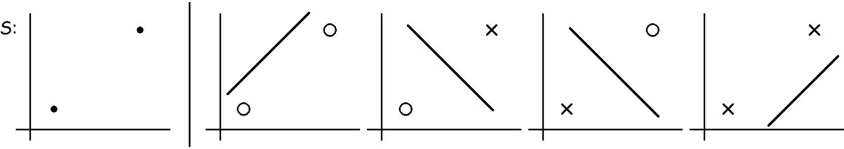

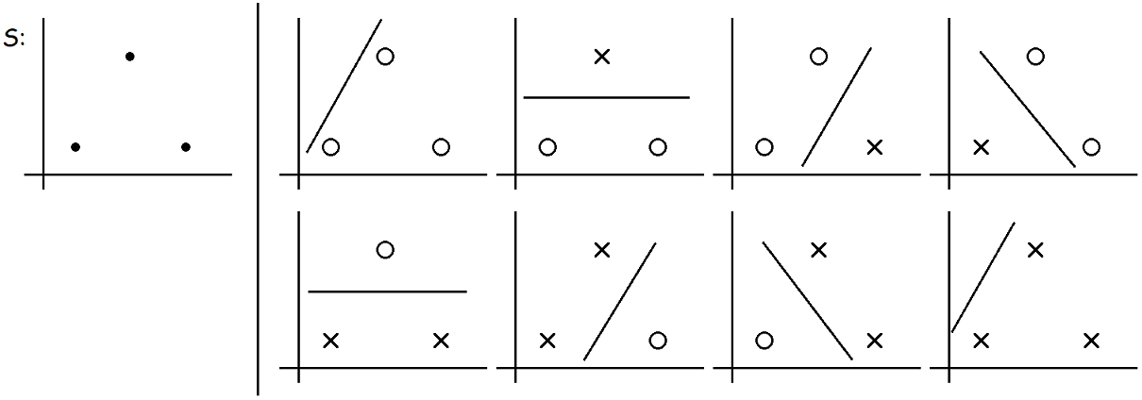

$$define$$

$$The Vapnik\text{-}Chervonenkis dimension of H (VC\left(H\right)) is the$$

$$size of the largest set shattered by H.$$

$e.g.$ $H=\left\{linear classifiers in 2\text{-}D\right\}, VC\left(H\right)=3$

$$\begin{matrix} \\ (because when \left|S\right|≥4, it can never be shattered by H!)\end{matrix}$$

*Q: this cannot shattered by $H$ situation?*

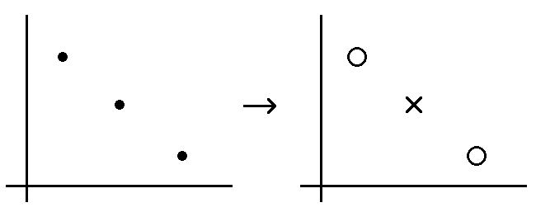

It doesn’t matter. Under the definition of the VC dimension, in order to prove that $VC\left(H\right)$ is at least $d$, we need to show only that there’s $just exist$ one set of size $d$ that $H$ can shatter.

$$More generally, in n\text{-}dimentions,$$

$$VC\left(\left\{linear classifiers in n\text{-}D\right\}\right)=n+1$$

With the definition of VC dimension, we can prove a theorem of the infinite $H$ (the progress of proof quite complicated, here just conclusion).

$$Let H be given and let VC\left(H\right)=d. Then w.p. (at least) 1-δ, we$$

$$have that ∀h∈H,$$

$\left|ε\left(h\right)-\hat{ε}\left(h\right)\right|≤O\left(\sqrt{\frac{d}{m}\log{\frac{m}{d}}+\frac{1}{m}\log{\frac{1}{δ}}}\right)$

$$Thus, w.p. (at least) 1-δ, we also have that$$

$ε\left(\hat{h}\right)≤ε\left(h^{*}\right)+(2)O\left(\sqrt{\frac{d}{m}\log{\frac{m}{d}}+\frac{1}{m}\log{\frac{1}{δ}}}\right)$

$$Corollary: To guarantee ε(\hat{h})≤ε(h^{*})+2γ, w.p. (at least)1-δ, it$$

$$suffices that$$

$$m=O_{γ,δ}\left(d\right)$$

It means that, if we want to minimize the gap between training error with generalization error whether the hypothesis is finite or infinite, the least number of training set must be the *same order* with (i.e. change with the same rate, cause it’s just a very loose bound that has implicitly considered worse or even the worst condition) the number of hypothetical features (VC dimension).

- digression: tie up some loose facts

#1 Large margin linear classifier (e.g. SVM), i.e.,

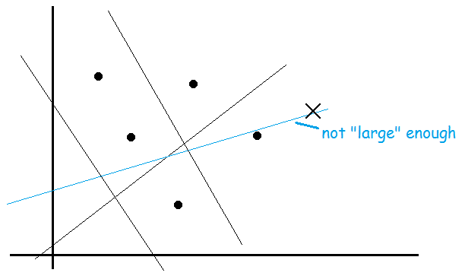

$$If {\left\|x^{\left(i\right)}\right\|}_{2}≤R,margin at least γ,$$

$$VC\left(H\right)≤\left\lceil \frac{R^{2}}{4γ^{2}}\right\rceil +1 (\left\lceil 4.23\right\rceil =5, \left\lceil -2.18\right\rceil =-2. Upper.)$$

$$\begin{matrix}{\left\|x\right\|}_{2}^{2}=\sum_{i=1}^{n}{x_{i}^{2}} (finite \#features) \\ {\left\|x\right\|}_{2}^{2}=\sum_{i=1}^{∞}{x_{i}^{2}} (infinite \#features)\end{matrix}$$

#2 ERM refers to logistic regression and SVM, i.e.,

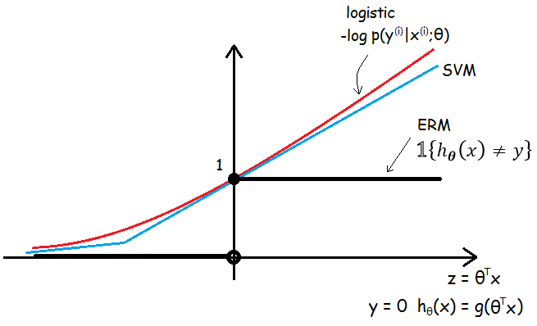

Considering only one parameter’s condition, logistic regression and SVM can be both viewed as the convex approximation of ERM(can also generalize), because the linear classifiers minimizing the training error is an NP-hard problem(not convex).

② Model selection: Cross validation & Feature Selection

(1) cross validation

Relationship between generalization error and model complexity is re-drawn as:

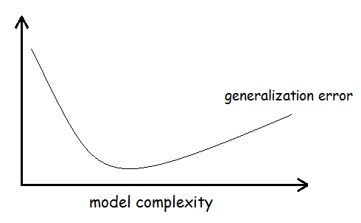

Consider 3 kinds of problems of selecting among several models for a learning problem:

🡪 Practically, these kinds of problems we assume we have some finite set of models

$$M=\left\{M_{1}, M_{2}, …, M_{d}\right\}$$

Here $M$ can consist of SVM, neural network, logistic regression etcetera.

🡪 *Hold-out cross validation* (or *simple cross validation*):

- Easy and fast to use especially in quite large sets, but not sufficiently enough.

🡪 *-fold cross validation*:

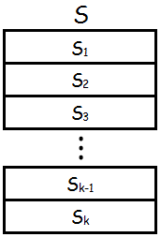

- Suit for data-scarce sets (e.g. $m=20$) and be more sufficient in using data, but inevitably accompany with more computational expense.

🡪 *Leave-one-out cross validation:* when $k=m$, with the extremely rare data.

(2) feature selection

Some special learning problems could be described as: the number of features $n$ is (extremely) larger than the number of training set $m (n≫m)$, but there is only a small number of features that are “(strongly) relevant” to the learning task. It means that

$$With n features, there are 2^{n} possible subsets.$$

However we almost cannot search for the very features through comparing all $2^{n}$ models, here we have got some heuristic search procedure as follows.

🡪 *Forward search*:

- The algorithm can be finally terminated in 2 situations: all features are in $F$, $or \left|F\right|$ exceeds some pre-set threshold (e.g. pre-set $\#output\text{-}features≤10$).

PS: It’s a kind of *“wrapper” model feature selection*.

*Backward search*:

🡪 *”Filter” feature selection*:

$$\begin{matrix}\begin{matrix}\left(1\right) Compute some simple score S(i) that measures how informative each \\ feature x_{i} is about the class labels y.\end{matrix} \\ \left(2\right) Pick the k features with the largest scores S(i) as the final output.\end{matrix}$$

E.g. $corr\left(x_{i},y\right)$

Here we can define *mutual information* (mainly in text problems):

$$MI\left(x_{i},y\right)=\sum_{x_{i}∈D}{\sum_{y∈O}{p\left(x_{i},y\right)\log{\frac{p\left(x_{i},y\right)}{p\left(x_{i}\right)p\left(y\right)}}}}$$

$D$ is all the results that $x_{i}$ can get (usually $\{0,1\}$), $O$ is the same. The probabilities $p(x_{i},y), p(x_{i}), p(y)$ can be estimated from training set.

Through information theory, we can also re-write the mutual information $MI(x_{i},y)$ as a *KL(Kullback-Leibler)-divergence*:

$$MI\left(x_{i},y\right)=KL\left(p\left(x_{i},y\right)∥p\left(x_{i}\right)p\left(y\right)\right)$$

Informally, this equation gives a measure of how different the probability distributions are. It is clearly that if $x_{i}$ and $y$ are independent random variables, the KL-divergence between will be 0.

Finally when we pick top $k$ features, we can also choose them using cross validation as measure!

**Lesson 11**

*Outline this Lesson:*

Learning Theory

1. Bayesian statistics & regularization

2. Digression: Online learning

3. Advice for applying ML algorithms

① Bayesian statistics & regularization

*“Frequentist”* view (e.g. Linear regression):

$$maximum likelihood$$

$$\begin{matrix}θ_{ML}=\arg{\max_{θ}{\prod_{i=1}^{m}{p\left(y^{\left(i\right)} | x^{\left(i\right)};θ\right)}}} \\ (θ is a constant\text{-}valued but unknown parameter)\end{matrix}$$

*\*“Bayesian”* view:

$$\begin{matrix}\begin{matrix}\begin{matrix}\begin{matrix}p\left(θ\right) \text{-} prior distribution & e.g. θ \sim N(0,τ^{2}I)\end{matrix} \\ Get S={\left\{\left(x^{\left(i\right)},y^{\left(i\right)}\right)\right\} }_{i=1}^{m} \\ Calculate p\left(θ | S\right)=\frac{p\left(S | θ\right)p\left(θ\right)}{p\left(S\right)} \text{-} posterior distribution\end{matrix} \\ \begin{matrix}To make a new prediction on x, \\ \begin{matrix}p\left(y | x,S\right)=\int_{θ}{p\left(y | x,θ\right)p\left(θ | S\right)dθ}(computationally difficult to get) \\ E\left[y | x,S\right]=\int_{y}{yp\left(y | x,S\right)dy}\end{matrix}\end{matrix} \\ (θ is a random variable)\end{matrix}\end{matrix}$$

Practically,

$\begin{matrix}\begin{matrix}{\hat{θ}}_{MAP}=\arg{\max_{θ}{p\left(θ | S\right)}}=\arg{\max_{θ}{\prod_{i=1}^{m}{p\left(y^{\left(i\right)} | x^{\left(i\right)},θ\right)}p\left(θ\right)}} \\ (here we view θ as a random variable, so p(y^{(i)}|x^{(i)},θ) means p(y^{(i)}|x^{(i)};θ))\end{matrix} \\ \begin{matrix}\begin{matrix}To make a new prediction,\end{matrix} \\ \hat{y}=h_{{\hat{θ}}_{MAP}}\left(x\right)={{\hat{θ}}_{MAP}}^{T}x\end{matrix}\end{matrix}$

$$e.g. linear regression problem can be regularized like:$$

$$\begin{matrix}{\hat{θ}}_{lr}=\arg{\min_{θ}{\sum_{i=1}^{m}{{\left\|y^{\left(i\right)}-θ^{T}x^{\left(i\right)}\right\|}^{2}}+λ{\left\|θ\right\|}^{2}}} \\ \begin{matrix} loss & prior\end{matrix}\end{matrix}$$

*\*Regularization can always be transformed by “loss + prior” type!*

proof as follows:

$${\hat{θ}}_{MAP}=\arg{\max_{θ}{\prod_{i=1}^{m}{p\left(y^{\left(i\right)} | x^{\left(i\right)},θ\right)}p\left(θ\right)}}$$

$$\begin{matrix}\begin{matrix}p\left(θ\right) \text{-} prior distribution\end{matrix}, straightly associated \\ \begin{matrix}p\left(y^{\left(i\right)} | x^{\left(i\right)},θ\right) \text{-} conditional pdf of set, same as p\left(y^{\left(i\right)} | x^{\left(i\right)};θ\right)\end{matrix}\end{matrix}$$

through **Lesson 3**, we can accordingly know that

🡪

🡪

🡪

② Digression: Online learning

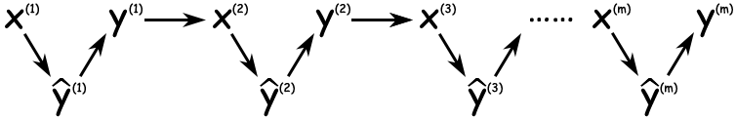

$$Total online error \left(at m moment\right):$$

$$ε_{ol}=\sum_{i=1}^{m}{1\left\{{\hat{y}}^{\left(i\right)}≠y^{\left(i\right)}\right\}}$$

$$e.g. Perceptron algorithm:$$

$$\begin{matrix}Initialize θ=\overset{⃑}{0}. \\ \begin{matrix}After i\# example, update \\ θ≔θ+α·\left(y^{\left(i\right)}-h_{θ}\left(x^{\left(i\right)}\right)\right)x^{\left(i\right)}\end{matrix}\end{matrix}$$

Online error can also solve some incredible problem, such as when we use perceptron algorithm but $x^{\left(i\right)}∈R^{∞}$, if it is proved that positive and negative examples are separated by a margin, perceptron algorithm can still converge to digital dimensional space. Total online error is at most $D^{2}/γ^{2} (∀i, \left\|x^{\left(i\right)}\right\|≤D; γ \text{-} the geometric margin).$

$$\left(PS: proof of this conclusion are in cs229\text{-}notes6.pdf, P.g. 2\sim 3\right)$$

*③ Advice for applying ML algorithms

Notes here are experiential for applying, might not suitable for researching. Some of these advice is debatable, but still make a dent in parts of problems.

(1) diagnostics for debugging learning algorithms

#1 Someone used Bayesian logistic regression to build up an anti-spam, which contains a small set of words as features, but got unacceptable 20% (or more) test error.

$$Bayesian logistic regression:$$

$$\max_{θ}{\sum_{i=1}^{m}{\log{p\left(y^{\left(i\right)} | x^{\left(i\right)},θ\right)}}-λ{\left\|θ\right\|}^{2}}$$

a) Common approach: Just try in different ways (quite randomly)

- Try getting more training examples.

- Try a smaller set of features.

- Try a larger set of features.

- Try changing the features: Email header vs. email body features.

- Run GD for more iterations.

- Try Newton’s method.

- Use a different value for .

- Try using an SVM.

This approach is time-consuming, gambly, sometimes it might work though.

b) Better approach: Diagnose and repair

- Run diagnostics to figure out what the problem truly is.

- Fix (or precisely optimize) whatever the problem is.

🡪 1) Suppose the problem is either (*bias vs. variance diagnostics*):

- Overfitting (high variance).

- Too few features to classify spam (high bias).

2) Diagnostic:

- Variance: Training error will be much lower than test error.

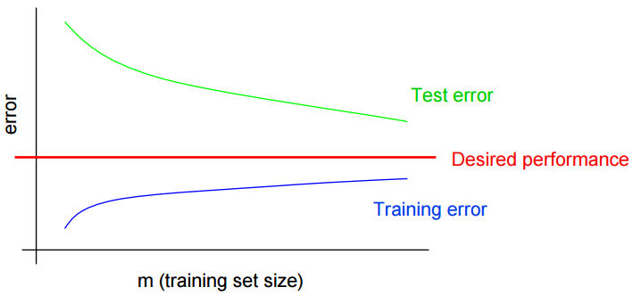

- Bias: Training error will also be high (although both are very closed of each other).

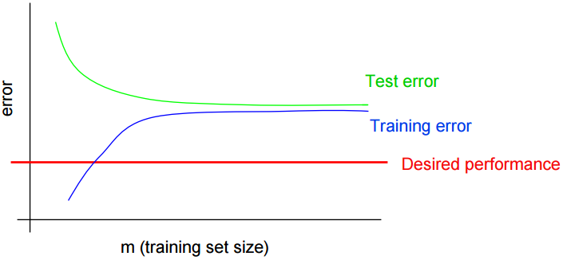

here, we can know what fixes to try:

- Try getting more training examples. Fixes high variance.

- Try a smaller set of features. Fixes high variance.

- Try a larger set of features. Fixes high bias.

- Try email header features. Fixes high bias.

For other problems, it’s usually up to ingenuity to design effective and unique diagnostics to figure out what’s wrong.

#2 Someone uses Bayesian logistic regression to build up an anti-spam, which gets 2% error on spam, and 2% error on non-spam. (Unacceptable error on non-spam.) He also applies SVM using a linear kernel, which gets 10% error on spam, and 0.01% error on non-spam (acceptable). Because of some reasons (like computational efficiency etc.), he chooses to use the former algorithm.

We can figure out lots of potential improvements (or questions) like:

- Is the algorithm converging?

- Optimize the right function?

- If using weight, need weights higher for non-spam than spam?

- Correct value for $λ$ in Bayesian logistic regression?

- Correct value for $C$ in SVM? …

And whatever reason, we really want to deploy Bayesian logistic regression, even though SVM does much better for this application.

*Q: What to do next?*

$$Say$$

$$\begin{matrix}\begin{matrix}θ_{SVM} \text{-} the parameters learned by an SVM \\ θ_{BLR} \text{-} the parameters learned by Bayesian logistic regression\end{matrix} \\ \begin{matrix}a\left(θ\right)=\max_{θ}{\sum_{i}{w^{\left(i\right)}·1\left\{h_{θ}\left(x^{\left(i\right)}\right)=y^{\left(i\right)}\right\}}} \text{-} the weighted accuracy\end{matrix}\end{matrix}$$

$$θ_{SVM} outperforms θ_{BLR}. So$$

$$a\left(θ_{SVM}\right)>a\left(θ_{BLR}\right)$$

BLR tries to maximize:

$$J\left(θ\right)=\sum_{i=1}^{m}{\log{p\left(y^{\left(i\right)} | x^{\left(i\right)},θ\right)}}-λ{\left\|θ\right\|}^{2}$$

Diagnostics:

- Problem is with optimization algorithm.

$$\begin{matrix}\left\{\begin{aligned}a\left(θ_{SVM}\right)>a\left(θ_{BLR}\right) \\ J\left(θ_{SVM}\right)>J\left(θ_{BLR}\right)\end{aligned}\right.\end{matrix}$$

It means that BLR tries to maximize $J$ but fails, because using SVM’s parameters $J$ can be larger than BLR’s. Obviously algorithm doesn’t converge well.

- Problem is with optimization objective function.

$$\begin{matrix}\left\{\begin{aligned}a\left(θ_{SVM}\right)>a\left(θ_{BLR}\right) \\ J\left(θ_{SVM}\right)≤J\left(θ_{BLR}\right)\end{aligned}\right.\end{matrix}$$

It shows that the SVM, which does worse on $J\left(θ\right)$, actually does better on weighted accuracy $a\left(θ\right)$. In other words, maximizing $J\left(θ\right)$ doesn’t really correspond that well to maximizing $a\left(θ\right)$. This confirms that if you care about $a\left(θ\right)$, $J\left(θ\right)$ is the wrong function to be maximizing.

here, we can know what fixes to try:

- Run GD for more iterations. Fixes optimization algorithm.

- Try Newton’s method. Fixes optimization algorithm.

- Use a different value for $λ$. Fixes optimization objective.

- Try using an SVM. Fixes optimization objective.

#3 Andrew Ng’s project on reinforcement learning: The Stanford Autonomous Helicopter.

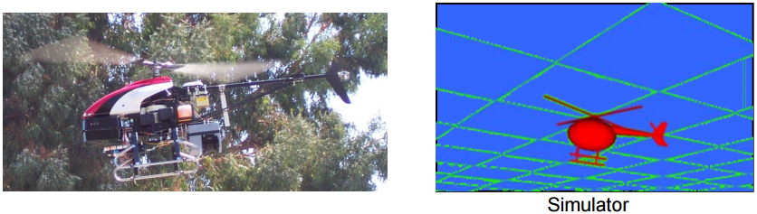

Build a simulator of helicopter 🡪 Choose a cost function🡪 minimize $J\left(θ\right)$ to get $θ_{RL}$

$$Say$$

$$\begin{matrix}\begin{matrix}J\left(θ\right)={\left\|x-x_{desired}\right\|}^{2} x \text{-} helicopter position \\ θ_{RL}=\arg{\min_{θ}{J\left(θ\right)}}\end{matrix}\end{matrix}$$

Suppose the resulting controller parameters gives much worse performance than human pilot. *What to do next?*

- Improve simulator?

- Modify cost function?

- Modify RL algorithm?

Diagnostics:

- Ifflies well in simulation, but not in reality. 🡪 Problem in simulation.

Letbe the human control policy.

- If, cost function is failed to minimize. 🡪 Problem in RL algorithm.

- If $J\left(θ_{human}\right)≥J\left(θ_{RL}\right)$, it means that minimizing $J$ doesn’t correspond to good autonomous flight. 🡪 Problem in cost function.

Conclusions:

We’ve got 3 different diagnostics of different learning problems. Practically, it’s just a little bit useful in some ways because it is quite often to come up with our own diagnostics (via ingenuity) to figure out what’s happening in different learning problems.

Moreover, even if a learning algorithm is working well, we can also run diagnostics to help us understand the algorithm further. This is useful for:

- Understanding application problems further, even getting an intuitive understand of what works and what doesn’t work.

- Writing research papers: enrich insight about the problem and justify research claims.

- Making sense and being convincible when explain the core algorithm to others.

🡪 So, we need *error analysis* to understand what sources of error are!

(2) error analysis & ablative analysis

a) error analysis

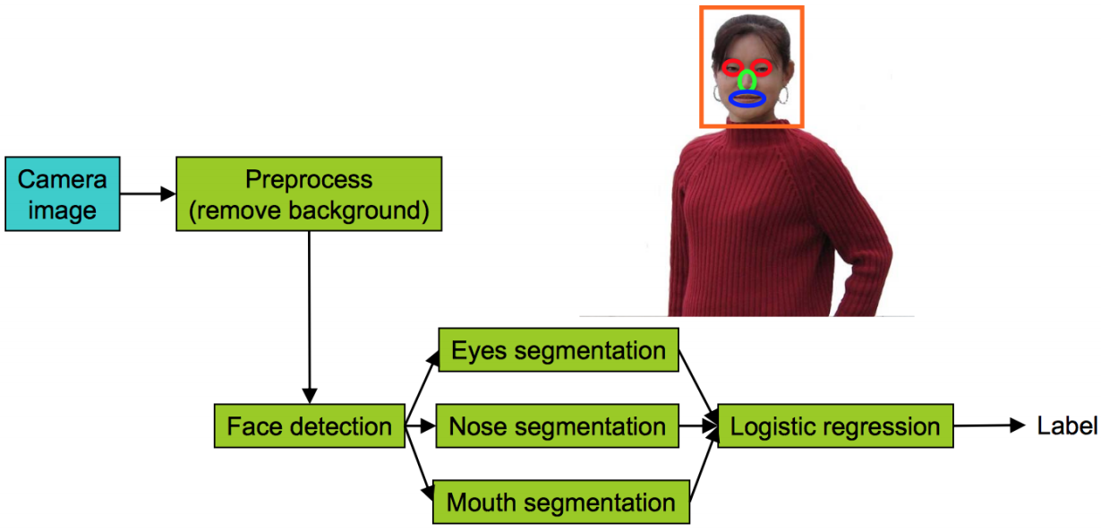

E.g. A pipeline of Face recognition from images (not quite formal)

Suppose we have a pipeline like above picture. Now the recognition accuracy of overall system is only 85%.

What we can do in brief, plug in *ground-truth* for each component, which means the perfect output of each component however it’s got (like using PS, coding by hand etc.), see how accuracy changes. Perhaps the changes can be noted as:

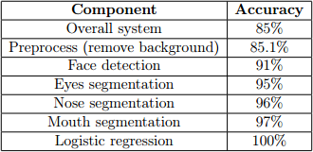

And then, find the several maximum gaps between and improve them first. In this case, we know that we have most room for improvement in face detection and eyes segmentation.

b) ablative analysis

Compared with error analysis, ablative analysis is the opposite strategy which tries to explain the difference between some baseline and current performance.

E.g. A good anti-spam classifier by adding lots of clever features to logistic regression:

- Spelling correction.

- Sender host features.

- Email header features.

- Email text parser features.

- Javascript parser.

- Features from images.

Q: How much did each of these components really help?

Suppose we apply a simple logistic regression without any clever features get 94% performance. In ablative analysis, just remove components from the system **one at a time** (not only one-by-one, one-out-others-in if suitable is ok) to see how it breaks. Perhaps the changes can be noted as:

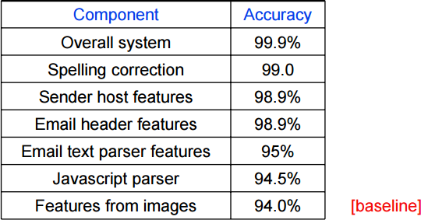

Accordingly, we can also find out the several maximum gaps between and figure out what is the core component of the system. In this case, it shows that email text parser features contribute for the most of the improvement.

From the discussion above, we can reorganize the both analysis briefly as:

|  |  |  |
| --- | --- | --- |
| Type | **Error Analysis** | **Ablative Analysis** |
| How | 1. Select suitable components  2. Make each “perfect” (*ground*  *-truth*), record the changes  3. Find out the most improving parts, focus on those | 1. Select suitable components  2.Remove each in some rules, record the changes  3. Find out the most decreasing parts, pay attention on those |
| Situation | Improve the algorithm or debug it. | Analysis improved algorithm, find out the core change(s). |

(3) how to get started on a learning problem

There are two typical approaches to applying learning algorithms:

#1 Design very carefully, then implement it.

Benefit: Nicer, perhaps more scalable algorithms. May come up with new, elegant, learning algorithms; contribute to basic research in machine learning.

Risk: *Premature* (*statistical*) *optimization*.

#2 Build a quick-and-dirty prototype, diagnose and fix it.

Benefit: Will often get application problem working more quickly. Faster time to market.

Risk: Time-consuming debugging and testing (if not quite experienced in some part).

**Lesson 12**

*Outline this Lesson:*

Unsupervised Learning

1. Clustering (k-means)

2. Mixture of Gaussians

3. Jensen’s inequality

4. EM (Expectation-Maximization) algorithm

① Clustering (k-means)

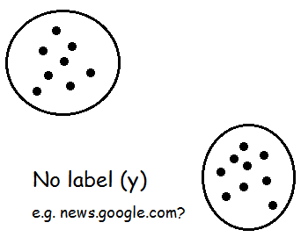

*K-means algorithm*:

$$\begin{matrix}Input training set \{x^{(1)},x^{(2)},…,x^{(m)}\}, x^{(i)}∈R^{n}. \\ 1. Initialize cluster centriods μ_{1},μ_{2},…,μ_{k}∈R^{n} randomly. \\ \begin{matrix}2. Repeat until convergence: \\ i) Set c^{\left(i\right)}≔\arg{\min_{j}\left\|x^{\left(i\right)}-μ_{j}\right\| (or {\left\|x^{\left(i\right)}-μ_{j}\right\|}^{\left(2\right)})}. \\ ii) μ_{j}≔\frac{\sum_{i=1}^{m}{1\left\{c^{\left(i\right)}=j\right\}x^{\left(i\right)}}}{\sum_{i=1}^{m}{1\left\{c^{\left(i\right)}=j\right\}}}.\end{matrix}\end{matrix}$$

This algorithm guarantees convergence by *distortion function*:

$$J\left(c,μ\right)=\sum_{i=1}^{m}{{\left\|x^{\left(i\right)}-μ_{c^{\left(i\right)}}\right\|}^{2}}$$

Here $c^{\left(i\right)}$ is a label of $x^{\left(i\right)}$ to decide one example $x^{\left(i\right)}$ belongs to which cluster centroid related. Moreover, $k$ (# clusters) is assumed already known, even though it is quite a problem to choose practically. If we are just curious about the minimum of $J\left(c,μ\right)$, we can choose this parameter “randomly” and choose that can minimize $J$. (I.e. the exact $k$ may vague as below.)

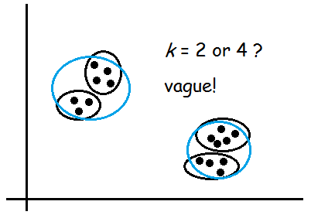

Algorithm above do those things in two steps: (i) “Assigning” each training example $x^{\left(i\right)}$ to the closest cluster centroid $μ_{j}$. (ii) Moving each $μ_{j}$ to the mean of the points assigned to it.

As a matter of fact, *k*-means is exactly coordinate descent on $J\left(c,μ\right)$. Because $J\left(c,μ\right)$ is a non-convex function, *k*-means can always converge, but not guarantee to converge to the global minimum. (Initialize cluster centroids randomly and choose the minimum $J$ may help.)

🡪 Density estimation

Here’s a practical example, we need to detect whether an aeroengine is broken or not (briefly) in such two potential factors: vibration and heat. The data all we have and the detected one, point *Q*, are shown as:

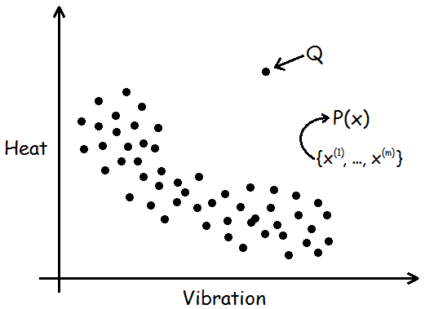

We can divide all training set into several clusters by *k*-means, then check *Q* belongs to none of them to figure out *Q* is the one need further inspected. Some problem like this are called *anormaly detection*. For brevity, we can describe the algorithm to solve those as:

$$\begin{matrix}1. Do density estimation to data set \left\{x^{\left(1\right)},…,x^{\left(m\right)}\right\} to build a model, get P\left(x\right). \\ 2. Calculate P\left(Q\right). \\ 3. Confirm the Q is anormal or not.\end{matrix}$$

In this part, we are curious about *step 1*: how to get $P\left(x\right)$, so called *density estimation*. Considering this situation, we can hardly build a model with all the basic distributions we have already known like Gaussian or Poisson etc. So a usual way to build complex models like this is to apply the mixture of Gaussians.

② Mixture of Gaussians

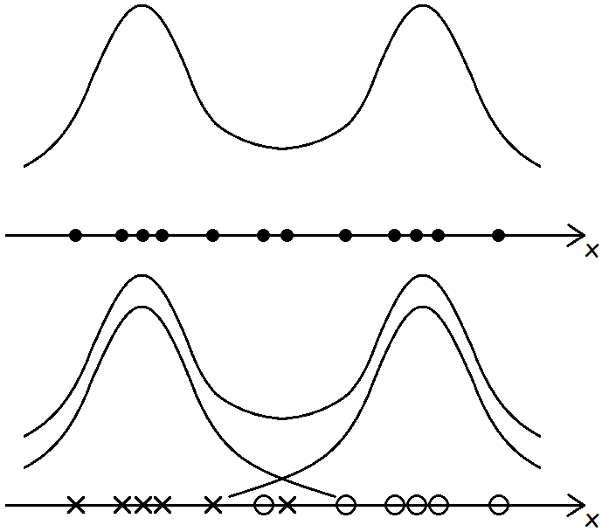

$$There^{'}s a latent \left(hidden/unobserved\right) random variable z in training data. And$$

$$x^{\left(i\right)}, z^{\left(i\right)} have a joint distribution (PS: k is \# z^{\left(i\right)}s can take on):$$

$$p\left(x^{\left(i\right)},z^{\left(i\right)}\right)=p\left(x^{\left(i\right)} | z^{\left(i\right)}\right)p\left(z^{\left(i\right)}\right)$$

$\begin{matrix}\begin{matrix} Here z^{(i)} \sim Multinomial(ϕ) \left(ϕ_{j}≥0, \sum_{j=1}^{k}{ϕ_{j}}=1\right) \\ \left.x^{(i)}\right|z^{(i)}=j \sim N\left(μ_{j}, Σ_{j}\right)\end{matrix}\end{matrix}$

$$If we knew z^{\left(i\right)}s,$$

$$l\left(ϕ,μ,Σ\right)=\sum_{i=1}^{m}{\log{p\left(x^{\left(i\right)},z^{\left(i\right)};ϕ,μ,Σ\right)}}$$

$$Maximizing it, we have:$$

$$\begin{matrix}ϕ_{j}=\frac{1}{m}\sum_{i=1}^{m}{1\left\{z^{\left(i\right)}=j\right\}} \\ μ_{j}=\frac{\sum_{i=1}^{m}{1\left\{z^{\left(i\right)}=j\right\}x^{\left(i\right)}}}{\sum_{i=1}^{m}{1\left\{z^{\left(i\right)}=j\right\}}} \\ Σ_{j}=\frac{\sum_{i=1}^{m}{1\left\{z^{\left(i\right)}=j\right\}\left(x^{\left(i\right)}-μ_{j}\right){\left(x^{\left(i\right)}-μ_{j}\right)}^{T}}}{\sum_{i=1}^{m}{1\left\{z^{\left(i\right)}=j\right\}}}\end{matrix}$$

As it’s shown above, it is quite similar with GDA in **Lesson 5**(here each Gaussian may vary because of the difference of ${ Σ}_{j}$). However, the fact is that we actually do *not* know $z^{\left(i\right)}s$. In order to satisfy this condition, we need special type of EM algorithm to help.

🡪 *EM* *algorithm (with mixture of Gaussians model)*:

$$\begin{matrix}repeat until convergence: \\ \begin{matrix} (E\text{-}step) For each i,j, let \\ w_{j}^{\left(i\right)}≔p\left(z^{\left(i\right)}=j\left|x^{\left(i\right)}\right.;ϕ,μ,Σ\right)\end{matrix} \\ \begin{matrix} (M\text{-}step) Update the parameters \\ \begin{matrix}ϕ_{j}≔\frac{1}{m}\sum_{i=1}^{m}{w_{j}^{\left(i\right)}} \\ μ_{j}≔\frac{\sum_{i=1}^{m}{w_{j}^{\left(i\right)}x^{\left(i\right)}}}{\sum_{i=1}^{m}{w_{j}^{\left(i\right)}}} \\ Σ_{j}≔\frac{\sum_{i=1}^{m}{w_{j}^{\left(i\right)}\left(x^{\left(i\right)}-μ_{j}\right){\left(x^{\left(i\right)}-μ_{j}\right)}^{T}}}{\sum_{i=1}^{m}{w_{j}^{\left(i\right)}}}\end{matrix}\end{matrix}\end{matrix}$$

We can apply Bayes’ Rule to expand *E-step* as:

$$w_{j}^{\left(i\right)}≔p\left(z^{\left(i\right)}=j\left|x^{\left(i\right)}\right.;ϕ,μ,Σ\right)$$

$$=\frac{p\left(x^{\left(i\right)}\left|z^{\left(i\right)}=j\right.;μ,Σ\right)p\left(z^{\left(i\right)}=j;ϕ\right)}{\sum_{l=1}^{k}{p\left(x^{\left(i\right)}\left|z^{\left(i\right)}=l\right.;μ,Σ\right)p\left(z^{\left(i\right)}=l;ϕ\right)}}$$

$$\begin{matrix}=\frac{\frac{1}{{\left(2π\right)}^{n/2}{\left|Σ_{j}\right|}^{1/2 }}\exp\left(-\frac{1}{2}{\left(x^{\left(i\right)}-μ_{j}\right)}^{T}Σ_{j}^{-1}\left(x^{\left(i\right)}-μ_{j}\right)\right)·ϕ_{j}}{\sum_{l=1}^{k}{\frac{1}{{\left(2π\right)}^{n/2}{\left|Σ_{l}\right|}^{1/2 }}\exp\left(-\frac{1}{2}{\left(x^{\left(i\right)}-μ_{l}\right)}^{T}Σ_{l}^{-1}\left(x^{\left(i\right)}-μ_{l}\right)\right)·ϕ_{l}}} \\ \left(n=\#features in x^{\left(i\right)}, k=\# z^{\left(i\right)}s can take on\right)\end{matrix}$$

Despite of computational difficulty, we can update $w^{(i)}$ easily. Practically, *k*-means can also be described as EM algorithm. Moreover, EM algorithm converges to the local minimum instead of the global minimum.

*Q: Does EM algorithm can always converge like k-means?*

- Need some other factors first, like Jensen’s inequality.

③ Jensen’s inequality

*Jensen’s inequality* actually is the property of convex functions or distributions, and it has lots of different forms in different ways. Here’s one useful form of them:

$$Let f be a convex function (i.e. f''(x)≥0), and let X be a random$$

$$variable. Then$$

$$f\left(EX\right)≤E\left[f\left(X\right)\right] (f(EX)=f(E[X]))$$

$$Moreover, if f is strictly convex (i.e. f''(x)>0), then$$

$$f\left(EX\right)=E\left[f\left(X\right)\right] ⇔ X=E\left[X\right] (i.e. X is a constant)$$

$$\left(On the contrary, all the inequalities just need reverse if f is concave!\right)$$

We can draw a picture to help us understand and remember it:

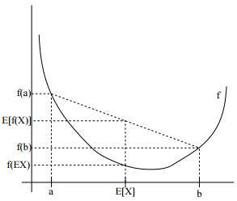

④ EM (Expectation-Maximization) algorithm

From the mixture of Gaussians part, we can conclude it and generalize such problem as follows:

$$\begin{matrix}1. Have training set \{x^{\left(1\right)},…,x^{\left(m\right)}\} with some latent variables z^{(i)}. \\ 2. Build model and want to find parameters for P\left(x,z;θ\right). \\ \begin{matrix}3. Want to maximize the likelihood: \\ \begin{matrix}l(θ)=\sum_{i=1}^{m}{\log{p(x^{(i)};θ)}} \\ =\sum_{i=1}^{m}{\log{\sum_{z^{(i)}}{p(x^{(i)},z^{(i)};θ)}}}\end{matrix}\end{matrix}\end{matrix}$$

Now the problem is transferred to find suitable $θ$ to maximize the likelihood. The general EM algorithm gives an efficient method instead of maximizing $l\left(θ\right)$ straightly: (i) repeatedly construct a lower-bound on $l\left(θ\right)$ (*E-step*); (ii) optimize that lower-bound (*M-step*). The overall process can also be drawn as a picture:

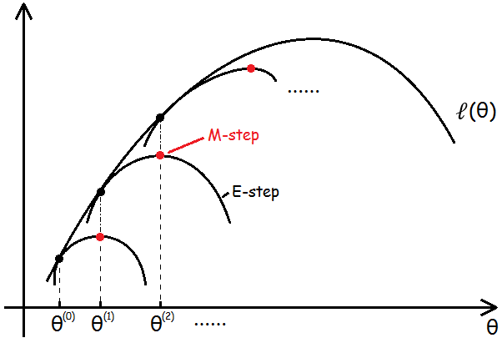

For each $i$, let $Q_{i}$ be some distribution over the $z^{(i)}s \left(\sum_{z}{Q_{i}\left(z\right)}=1, Q_{i}\left(z\right)≥0\right)$, we get:

$$\begin{matrix}\begin{matrix}l(θ)=\sum_{i}{\log{\sum_{z^{\left(i\right)}}{p(x^{(i)},z^{(i)};θ)}}} \\ \begin{matrix} =\sum_{i}{\log{\sum_{z^{\left(i\right)}}{Q_{i}\left(z^{\left(i\right)}\right)\frac{p(x^{(i)},z^{(i)};θ)}{Q_{i}\left(z^{(i)}\right)}}}} \\ \left(\begin{aligned}\sum_{i}{\log{\underset{z^{\left(i\right)}\sim Q_{i}}{E}\left[\frac{p(x^{(i)},z^{(i)};θ)}{Q_{i}\left(z^{(i)}\right)}\right]}} \\ use Jensen's quality (concave)\end{aligned}\right)\end{matrix} \\ ≥\sum_{i}{\sum_{z^{\left(i\right)}}{Q_{i}\left(z^{\left(i\right)}\right)\log{\frac{p(x^{(i)},z^{(i)};θ)}{Q_{i}\left(z^{(i)}\right)}}}}\end{matrix}\end{matrix}$$

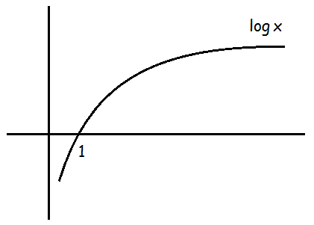Here we use some little tricks:

$$\begin{matrix}\begin{matrix}\begin{matrix}1. If z \sim p, we have g\left(z\right). Then \\ E[g(z)]=\sum_{z}{p(z)g(z)}\end{matrix} \\ 2. \log{E[x]}≥E[\log{x}]\end{matrix}\end{matrix}$$

According to the above equations, we know that for ***any $Q_{i}$***satisfied those given conditions, we have a lower-bound on $l\left(θ\right)$.

*Q: How to choose the very?*

- Want fit the inequation’s equality sign, in other words, make the lower-bound **tight**!

$$\frac{p\left(x^{\left(i\right)},z^{\left(i\right)};θ\right)}{Q_{i}\left(z^{(i)}\right)}=constant (for all values of z^{(i)})$$

$∴ Q_{i}\left(z^{(i)}\right) ∝ p\left(x^{\left(i\right)},z^{\left(i\right)};θ\right)$ $\sum_{z}{Q_{i}\left(z^{(i)}\right)} ∝ \sum_{z}{p\left(x^{\left(i\right)},z;θ\right)}$

$$\begin{matrix} \frac{Q_{i}\left(z^{(i)}\right)}{\sum_{z}{Q_{i}\left(z^{(i)}\right)}}=\frac{p\left(x^{\left(i\right)},z^{\left(i\right)};θ\right)}{\sum_{z}{p\left(x^{\left(i\right)},z;θ\right)}}\end{matrix}$$

Since we know $\sum_{z}{Q_{i}\left(z\right)}=1$,

$$∴ Q_{i}\left(z^{(i)}\right)=\frac{p\left(x^{\left(i\right)},z^{\left(i\right)};θ\right)}{\sum_{z}{p\left(x^{\left(i\right)},z;θ\right)}}$$

$$=\frac{p\left(x^{\left(i\right)},z^{\left(i\right)};θ\right)}{p\left(x^{\left(i\right)};θ\right)}$$

$$=p\left(z^{\left(i\right)}\left|x^{\left(i\right)}\right.;θ\right) (conditional probablility)$$

Thus, we simply set the $Q_{i}s$ to be the posterior distribution of the $z^{(i)}s,$ given $x^{(i)}$ and parameterized by $θ$.

Finally, we can give out the *generalized EM (Expectation-Maximization) algorithm*:

$$\begin{matrix}repeat until convergence: \\ \begin{matrix} (E\text{-}step) For each i, set \\ Q_{i}\left(z^{\left(i\right)}\right)≔p\left(z^{\left(i\right)}\left|x^{\left(i\right)}\right.;θ\right)\end{matrix} \\ \begin{matrix} (M\text{-}step) Update the parameters \\ θ≔\arg{\max_{θ}{\sum_{i}{\sum_{z^{\left(i\right)}}{Q_{i}\left(z^{\left(i\right)}\right)\log{\frac{p(x^{(i)},z^{(i)};θ)}{Q_{i}\left(z^{(i)}\right)}}}}}} \end{matrix}\end{matrix}$$

**Lesson 13**

*Outline this Lesson:*

EM

1. Mixture of Gaussians

2. Mixture of naive Bayes

3. Digression: Gaussians

4. Factor analysis

① EM: Mixture of Gaussians

- Another perspective of EM (in optimization)

- Mixture of Gaussians

According to the process above in **Lesson 12**, we know that in *E-step*:

$$w_{j}^{\left(i\right)}=Q_{i}\left(z^{\left(i\right)}=j\right)=p\left(z^{\left(i\right)}=j\left|x^{\left(i\right)}\right.;ϕ,μ,Σ\right)$$

$$=\frac{p\left(x^{\left(i\right)}\left|z^{\left(i\right)}=j\right.;μ,Σ\right)p\left(z^{\left(i\right)}=j;ϕ\right)}{\sum_{l=1}^{k}{p\left(x^{\left(i\right)}\left|z^{\left(i\right)}=l\right.;μ,Σ\right)p\left(z^{\left(i\right)}=l;ϕ\right)}}$$

$\begin{matrix}\begin{matrix} \left.x^{(i)}\right|z^{(i)}=j \sim N\left(μ_{j}, Σ_{j}\right) \\ z^{(i)} \sim Multinomial(ϕ) \left(ϕ_{j}≥0, \sum_{j=1}^{k}{ϕ_{j}}=1\right)\end{matrix}\end{matrix}$

So, *M-step*:

$$\max_{ϕ,μ,Σ}{\sum_{i}{\sum_{z^{\left(i\right)}}{Q_{i}\left(z^{\left(i\right)}\right)\log{\frac{p(x^{(i)},z^{(i)};ϕ,μ,Σ)}{Q_{i}\left(z^{(i)}\right)}}}}}$$

$$=\max_{ϕ,μ,Σ}{\sum_{i}{\sum_{j}{w_{j}^{\left(i\right)}\log{\frac{p(x^{\left(i\right)}|z^{\left(i\right)}=j;μ,Σ)p\left(z^{\left(i\right)}=j;ϕ\right)}{w_{j}^{\left(i\right)}}}}}}$$

$$=\max_{ϕ,μ,Σ}{\sum_{i}{\sum_{j}{w_{j}^{\left(i\right)}\log{\frac{\exp{(-\frac{1}{2}{(x^{\left(i\right)}-μ_{j})}^{T}Σ_{j}^{-1}(x^{\left(i\right)}-μ_{j}))}·ϕ_{j}}{{(2π)}^{n/2}{\left|Σ_{j}\right|}^{1/2 }·w_{j}^{\left(i\right)}}}}}}$$

$$define$$

$$G(ϕ,μ,Σ)=\sum_{i}{\sum_{j}{w_{j}^{\left(i\right)}\log{\frac{\exp{(-\frac{1}{2}{(x^{\left(i\right)}-μ_{j})}^{T}Σ_{j}^{-1}(x^{\left(i\right)}-μ_{j}))}·ϕ_{j}}{{(2π)}^{n/2}{\left|Σ_{j}\right|}^{1/2 }·w_{j}^{\left(i\right)}}}}}$$

#1 maximize $G\left(ϕ,μ,Σ\right)$ with respect to

🡪 Compute the update rule of $μ_{l}$:

$$μ_{l}≔\frac{\sum_{i=1}^{m}{w_{l}^{\left(i\right)}x^{\left(i\right)}}}{\sum_{i=1}^{m}{w_{l}^{\left(i\right)}}}$$

#2 maximize $G\left(ϕ,μ,Σ\right)$ with respect to $ϕ_{j}$

$$∵∇_{ϕ_{j}}G\left(ϕ,μ,Σ\right)=∇_{ϕ_{j}}\sum_{i=1}^{m}{\sum_{j=1}^{k}{w_{j}^{\left(i\right)}("constant to ϕ_{j}"+\log{ϕ_{j}})}}$$

$$=∇_{ϕ_{j}}\sum_{i=1}^{m}{\sum_{j=1}^{k}{w_{j}^{\left(i\right)}\log{ϕ_{j}}}}$$

$\left(ϕ_{j}≥0, \sum_{j=1}^{k}{ϕ_{j}}=1\right)$

Considering the constraint of $ϕ_{j}$, we can construct the Lagrangian ($ϕ_{j}≥0$ is naturally satisfied because of log function):

$$L\left(ϕ\right)=\sum_{i=1}^{m}{\sum_{j=1}^{k}{w_{j}^{\left(i\right)}\log{ϕ_{j}}}}+β\left(\sum_{j=1}^{k}{ϕ_{j}}-1\right)$$

$$\frac{∂}{∂ϕ_{j}}L\left(ϕ\right)=\frac{1}{ϕ_{j}}\sum_{i=1}^{m}{w_{j}^{\left(i\right)}}+β \underset{→}{set} \vec{0}$$

$$ϕ_{j}=\frac{\sum_{i=1}^{m}{w_{j}^{\left(i\right)}}}{-β} \left(ϕ_{j}∝\sum_{i=1}^{m}{w_{j}^{\left(i\right)}}\right)$$

Similar to the equation in **Lesson 12**, we have so it’s easily to figure out the Lagrange multiplier

🡪 Compute the update rule of $ϕ_{j}$:

$$ϕ_{j}≔\frac{1}{m}\sum_{i=1}^{m}{w_{j}^{\left(i\right)}}$$

#3 maximize $G\left(ϕ,μ,Σ\right)$ with respect to

🡪 Figure out the update rule of $Σ_{j}$:

$$Σ_{j}≔\frac{\sum_{i=1}^{m}{w_{j}^{\left(i\right)}\left(x^{\left(i\right)}-μ_{j}\right){\left(x^{\left(i\right)}-μ_{j}\right)}^{T}}}{\sum_{i=1}^{m}{w_{j}^{\left(i\right)}}}$$

② EM: Mixture of naive Bayes

Here’s a Text Clustering example (Multi-variant Bayes event model)

$$Assume$$

$$\begin{matrix}\begin{matrix}training set \left\{x^{\left(1\right)},…,x^{\left(m\right)}\right\} \\ x^{\left(i\right)}∈{\left\{0,1\right\}}^{n}, x_{j}^{\left(i\right)}=1\left\{word j appears in document i\right\}\end{matrix} \\ z^{\left(i\right)}∈\left\{0,1\right\} (2 clusters), z^{\left(i\right)} \sim Bernoulli\left(ϕ\right)\end{matrix}$$

$$thus$$

$$\begin{matrix} P\left(x^{\left(i\right)} | z^{\left(i\right)}\right)=\prod_{i=1}^{n}{P\left(x_{j}^{\left(i\right)} | z^{\left(i\right)}\right)} \\ P\left(x_{j}^{\left(i\right)}=1 | z^{\left(i\right)}=0\right)=ϕ_{\left.j\right|z=0}\end{matrix}$$

So, EM algorithm of this model

$$\begin{matrix}repeat until convergence: \\ \begin{matrix} E\text{-}step: \\ w^{\left(i\right)}≔p\left(z^{\left(i\right)}=1\left|x^{\left(i\right)}\right.;ϕ_{\left.j\right|z},ϕ\right)\end{matrix}\end{matrix}$$

$$\begin{matrix} M\text{-}step: \\ \begin{matrix} ϕ_{\left.j\right|z=1}≔\frac{\sum_{i=1}^{m}{w^{\left(i\right)}1\left\{x_{j}^{\left(i\right)}=1\right\}}}{\sum_{i=1}^{m}{w^{\left(i\right)}}} \\ ϕ_{\left.j\right|z=0}≔\frac{\sum_{i=1}^{m}{\left(1-w^{\left(i\right)}\right)1\left\{x_{j}^{\left(i\right)}=1\right\}}}{\sum_{i=1}^{m}{\left(1-w^{\left(i\right)}\right)}} \\ ϕ_{z}≔\frac{\sum_{i=1}^{m}{w^{\left(i\right)}}}{m}\end{matrix} \end{matrix}$$

The parameter $w^{\left(i\right)}s$ here are almost similar to 1 or 0 (e.g. 0.999/0.00001). Obviously, in *M-step* we treat $z$ as GDA’s $y$ and keep updating all the parameters till convergence.

③ Digression: Gaussians

Most models we have discussed above in unsupervised learning satisfy $m≫n$. For instance, here’s a simplified GMM data:

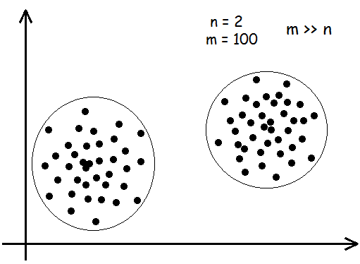

And we have

$$\begin{matrix}\begin{matrix} \left\{x^{\left(1\right)},…,x^{\left(m\right)}\right\} build p\left(x\right) \\ x \sim N\left(μ,Σ\right), Σ∈R^{n×n}\end{matrix} \\ μ=\frac{1}{m}\sum_{i=1}^{m}{x^{\left(i\right)}}, Σ=\frac{1}{m}\sum_{i=1}^{m}{(x^{\left(i\right)}-μ){(x^{\left(i\right)}-μ)}^{T}}\end{matrix}$$

When $n≈m$ or even $n≫m$, we’ll find that the matrix $Σ$ is singular. Because of this problem, $Σ^{-1}$ and $\left|Σ\right|$ do not exist, which means the model itself cannot describe this situation to solve the core problem we really concern in this way.

Here’s a quite impressive example to describe such a problem, the numbers of training set and features are both 2, the potential Gaussian model would be a very narrow ellipse (infinite width and very thin height).

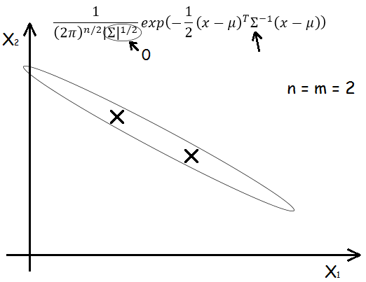

*Q: How to deal with it?*

- Use some restrictions of $Σ$.

$$\begin{matrix}Make Σ diagonal. \\ \begin{matrix}\left.\begin{matrix}Σ=diag\left(σ_{1}^{2},σ_{2}^{2},…,σ_{n}^{2}\right)=\left(\begin{matrix}σ_{1}^{2} & 0 & 0 \\ 0 & ⋱ & 0 \\ 0 & 0 & σ_{n}^{2}\end{matrix}\right)∈R^{n×n} \\ σ_{j}^{2}=\frac{1}{m}\sum_{i=1}^{m}{{\left(x_{j}^{\left(i\right)}-μ_{j}\right)}^{2}}\end{matrix} \right| & \begin{matrix}Σ=σ^{2}I=\left(\begin{matrix}σ^{2} & 0 & 0 \\ 0 & ⋱ & 0 \\ 0 & 0 & σ^{2}\end{matrix}\right) \\ σ^{2}=\frac{1}{mn}\sum_{j=1}^{n}{\sum_{i=1}^{m}{{\left(x_{j}^{\left(i\right)}-μ_{j}\right)}^{2}}}\end{matrix}\end{matrix}\end{matrix}$$

The right side restriction is stricter than left side if necessary. Even both method can rebui-ld model to fit, however, they will model the orthogonal features of data which means each fe-ature is uncorrelated and independent. Often, we are curious about the correlation structure in the data. We need to build a *factor analysis model*, which use parameters than the diagonal and captures some correlations in the data, without having to fit a full covariance matrix.

- Marginals and conditionals of Gaussians

$$Joint multivariate Gaussian distribution$$

$$assume$$

$$\begin{matrix}\begin{matrix} x=\left[ \begin{matrix}x_{1} \\ x_{2}\end{matrix} \right], x \sim N\left(μ,Σ\right) where \\ (x_{1}∈R^{r}, x_{2}∈R^{s}, x∈R^{r+s})\end{matrix} \\ \begin{matrix}μ=\left[ \begin{matrix}μ_{1} \\ μ_{2}\end{matrix} \right], Σ=\left[ \begin{matrix}Σ_{11} & Σ_{12} \\ Σ_{21} & Σ_{22}\end{matrix} \right] \\ (μ_{1}∈R^{r}, μ_{2}∈R^{s},Σ_{11}∈R^{r×r}, Σ_{12}=Σ_{21}^{T}∈R^{r×s}, Σ_{22}∈R^{s×s})\end{matrix}\end{matrix}$$

$$thus$$

$$E\left[x\right]=μ=\left[ \begin{matrix}μ_{1} \\ μ_{2}\end{matrix} \right]$$

$$\begin{matrix}\begin{matrix}Cov\left(x\right)=Σ \\ =\left[ \begin{matrix}Σ_{11} & Σ_{12} \\ Σ_{21} & Σ_{22}\end{matrix} \right]\end{matrix} \\ \begin{matrix}=E\left[\left(x-μ\right){\left(x-μ\right)}^{T}\right] \\ =E\left[ \begin{matrix}\left(x_{1}-μ_{1}\right){\left(x_{1}-μ_{1}\right)}^{T} & \left(x_{1}-μ_{1}\right){\left(x_{2}-μ_{2}\right)}^{T} \\ \left(x_{2}-μ_{2}\right){\left(x_{1}-μ_{1}\right)}^{T} & \left(x_{2}-μ_{2}\right){\left(x_{2}-μ_{2}\right)}^{T}\end{matrix} \right]\end{matrix}\end{matrix}$$

Since marginal distributions of Gaussians are themselves Gaussian and above shows that

$x_{1} \sim N\left(μ_{1},Σ_{11}\right)$, we can also figure out the conditional distribution of $x_{1}$ given $x_{2}$ as $x_{1}\left|x_{2}\right. \sim N\left(μ_{1\left|2\right.},Σ_{1\left|2\right.}\right)$, where

$$μ_{1\left|2\right.}=μ_{1}+Σ_{12}Σ_{22}^{-1}\left(x_{2}-μ_{2}\right) (1)$$

$$Σ_{1\left|2\right.}=Σ_{11}-Σ_{12}Σ_{22}^{-1}Σ_{21} (2)$$

It’ll be helpful in the next part. (the details of conditional distribution parameters’ proof at *references: more_on_gaussians Pg. 8*. PS: pay very attention to get $Σ^{-1}$, partitioned matrix!)

④ Factor analysis

Posit a joint distribution on $\left(x,z\right)$ as follows, here $z$ is a latent random variable:

$$\begin{matrix} z \sim N\left(0,I\right) z∈R^{d} (d<n) \\ x\left|z\right. \sim N\left(μ+Λz,ψ\right)\end{matrix}$$

Equivalently, we can also define that

$$\begin{matrix}\begin{matrix} ε \sim N\left(0,ψ\right) \\ x=μ+Λz+ε\end{matrix} \\ (μ∈R^{n}, Λ∈R^{n×d}, diagonal ψ∈R^{n×n}. z, ε are independent.)\end{matrix}$$

E.g.

$$\begin{matrix}z∈R^{1}, x∈R^{2}. z^{\left(i\right)} \sim N\left(0,1\right) \\ Λ=\left[ \begin{matrix}2 \\ 1\end{matrix} \right], μ=\left[ \begin{matrix}0 \\ 0\end{matrix} \right], ψ=\left[ \begin{matrix}1 & 0 \\ 0 & 2\end{matrix} \right]\end{matrix}$$

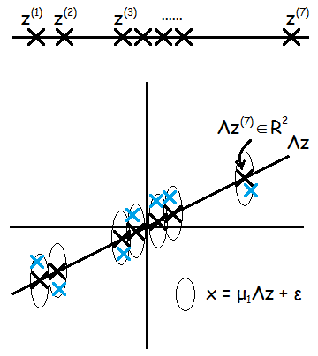

So, $z$ and $x$ have a joint Gaussian distribution

🡪

🡪

Moreover, we can also figure out the marginal distribution of $z$ is given by

$$x \sim N\left(μ,ΛΛ^{T}+ψ\right)$$

So, we can write down the log likelihood through a given training set $\left\{x^{\left(i\right)};i=1,…,m\right\}$

$$l\left(μ,Λ,ψ\right)=\log{\prod_{i=1}^{m}{p\left(x^{\left(i\right)};μ,Λ,ψ\right)}}$$

$$=\log{\prod_{i=1}^{m}{\frac{1}{{\left(2π\right)}^{n/2}{\left|ΛΛ^{T}+ψ\right|}^{1/2}}\exp\left(-\frac{1}{2}{\left(x^{\left(i\right)}-μ\right)}^{T}{\left(ΛΛ^{T}+ψ\right)}^{-1}\left(x^{\left(i\right)}-μ\right)\right)}}$$

Accordingly, *EM algorithm of factor analysis model* is described as follows:

$$\begin{matrix}repeat until convergence: \\ \begin{matrix} E\text{-}step: \\ \begin{matrix}Q_{i}\left(z^{\left(i\right)}\right)≔p\left(z^{\left(i\right)}\left|x^{\left(i\right)}\right.;μ_{\left.z^{(i)}\right|x^{(i)}},Σ_{\left.z^{(i)}\right|x^{(i)}}\right)\end{matrix}\end{matrix}\end{matrix}$$

$$\begin{matrix}μ_{\left.z^{(i)}\right|x^{(i)}}=Λ^{T}{\left(ΛΛ^{T}+ψ\right)}^{-1}\left(x^{\left(i\right)}-μ\right) \\ Σ_{\left.z^{(i)}\right|x^{(i)}}=I-Λ^{T}{\left(ΛΛ^{T}+ψ\right)}^{-1}Λ\end{matrix}, use (1)(2)(3)$$

$$M\text{-}step:$$

$$\begin{matrix}Θ≔\arg{\max_{Θ}{\sum_{i=1}^{m}{\int_{z^{\left(i\right)}}{Q_{i}\left(z^{\left(i\right)}\right)\log{\frac{p\left(x^{\left(i\right)},z^{\left(i\right)};μ,Λ,ψ\right)}{Q_{i}\left(z^{\left(i\right)}\right)}}dz^{\left(i\right)}}}}}\end{matrix}$$

$$=\arg{\max_{Θ}{\sum_{i=1}^{m}{E_{z^{\left(i\right)}\sim Q_{i}}\left[\log{\frac{p\left(x^{\left(i\right)}\left|z^{\left(i\right)}\right.;μ,Λ,ψ\right)p\left(z^{\left(i\right)}\right)}{Q_{i}\left(z^{\left(i\right)}\right)}}\right]}}}$$

$$=\arg{\max_{Θ}{\sum_{i=1}^{m}{E_{z^{\left(i\right)}\sim Q_{i}}\left[\log{p\left(x^{\left(i\right)}\left|z^{\left(i\right)}\right.;μ,Λ,ψ\right)}\right]}}}$$

$$\begin{matrix}(here Θ represents μ,Λ,ψ)\end{matrix}$$

**Here $Q_{i}\left(z^{\left(i\right)}\right)$ in *M-step* of one loop is a *fixed* part just after *E-step* finished.

**Lesson 14**

*Outline this Lesson:*

1. Factor analysis: EM steps

2. Principal Component Analysis (PCA)

① Factor analysis: EM steps

From **Lesson 13**, we can figure out that *EM algorithm of factor analysis model* can be described as follows:

$$\begin{matrix}repeat until convergence: \\ \begin{matrix} E\text{-}step: \\ \begin{matrix}Q_{i}\left(z^{\left(i\right)}\right)≔p\left(z^{\left(i\right)}\left|x^{\left(i\right)}\right.;μ_{\left.z^{(i)}\right|x^{(i)}},Σ_{\left.z^{(i)}\right|x^{(i)}}\right)\end{matrix}\end{matrix}\end{matrix}$$

$$\begin{matrix}μ_{\left.z^{(i)}\right|x^{(i)}}=Λ^{T}{\left(ΛΛ^{T}+ψ\right)}^{-1}\left(x^{\left(i\right)}-μ\right) \\ Σ_{\left.z^{(i)}\right|x^{(i)}}=I-Λ^{T}{\left(ΛΛ^{T}+ψ\right)}^{-1}Λ\end{matrix}$$

$$M\text{-}step:$$

$$\begin{matrix}Θ≔\arg{\max_{Θ}{\sum_{i=1}^{m}{\int_{z^{\left(i\right)}}{Q_{i}\left(z^{\left(i\right)}\right)\log{\frac{p\left(x^{\left(i\right)},z^{\left(i\right)};μ,Λ,ψ\right)}{Q_{i}\left(z^{\left(i\right)}\right)}}dz^{\left(i\right)}}}}}\end{matrix}$$

$$=\arg{\max_{Θ}{\sum_{i=1}^{m}{E_{z^{\left(i\right)}\sim Q_{i}}\left[\log{p\left(x^{\left(i\right)}\left|z^{\left(i\right)}\right.;μ,Λ,ψ\right)}\right]}}}$$

$$\begin{matrix}(here Θ represents μ,Λ,ψ)\end{matrix}$$

Here, we want to get the exact *M-step*, the update form of exact parameters $μ,Λ,ψ$ instead of $Θ$ step by step**.** First, we write down the complete form of “max” goal.

$$\begin{matrix}\max_{Θ}{\sum_{i=1}^{m}{E_{z^{\left(i\right)}\sim Q_{i}}\left[\log{p\left(x^{\left(i\right)}\left|z^{\left(i\right)}\right.;μ,Λ,ψ\right)}\right]}}\end{matrix}$$

$$=\max_{Θ}{\sum_{i=1}^{m}{E_{z^{\left(i\right)}\sim Q_{i}}\left[\log{\frac{1}{{\left(2π\right)}^{n/2}{\left|ψ\right|}^{1/2}}\exp\left(-\frac{1}{2}{\left(x^{\left(i\right)}-μ-Λz^{\left(i\right)}\right)}^{T}ψ^{-1}\left(x^{\left(i\right)}-μ-Λz^{\left(i\right)}\right)\right)}\right]}}$$

$$=\max_{Θ}{\sum_{i=1}^{m}{E_{z^{\left(i\right)}\sim Q_{i}}\left[-\frac{1}{2}{\left(x^{\left(i\right)}-μ-Λz^{\left(i\right)}\right)}^{T}ψ^{-1}\left(x^{\left(i\right)}-μ-Λz^{\left(i\right)}\right)-\frac{1}{2}\log\left|ψ\right|-\frac{n}{2}\log{2π}\right]}}$$

$$define$$

$$G(μ,Λ,ψ)=\sum_{i=1}^{m}{E_{z^{\left(i\right)}\sim Q_{i}}\left[-\frac{1}{2}{\left(x^{\left(i\right)}-μ-Λz^{\left(i\right)}\right)}^{T}ψ^{-1}\left(x^{\left(i\right)}-μ-Λz^{\left(i\right)}\right)-\frac{1}{2}\log\left|ψ\right|-\frac{n}{2}\log{2π}\right]}$$

#1 get $μ$:

$$∇_{μ}G\left(μ,Λ,ψ\right)=∇_{μ}\sum_{i=1}^{m}{E_{z^{\left(i\right)}\sim Q_{i}}\left[-\operatorname{tr}{\frac{1}{2}μ^{T}ψ^{-1}μ}+\operatorname{tr}{μ^{T}ψ^{-1}\left(x^{\left(i\right)}-Λz^{\left(i\right)}\right)}\right]}$$

$$=\sum_{i=1}^{m}{E_{z^{\left(i\right)}\sim Q_{i}}\left[ψ^{-1}\left(x^{\left(i\right)}-Λz^{\left(i\right)}-μ\right)\right]} \underset{→}{set} \vec{0}$$

$$∴ μ=\frac{1}{m}\sum_{i=1}^{m}{x^{\left(i\right)}}$$

Here $μ$ is a fixed parameter when update.

#2 get $Λ$:

$$∇_{Λ}G\left(μ,Λ,ψ\right)=∇_{Λ}\sum_{i=1}^{m}{E_{z^{\left(i\right)}\sim Q_{i}}\left[-\operatorname{tr}{\frac{1}{2}Λ^{T}ψ^{-1}Λz^{\left(i\right)}{z^{\left(i\right)}}^{T}}+\operatorname{tr}{Λ^{T}ψ^{-1}\left(x^{\left(i\right)}-μ\right){z^{\left(i\right)}}^{T}}\right]}$$

$$=\sum_{i=1}^{m}{E_{z^{\left(i\right)}\sim Q_{i}}\left[-ψ^{-1}\left(Λz^{\left(i\right)}{z^{\left(i\right)}}^{T}-\left(x^{\left(i\right)}-μ\right){z^{\left(i\right)}}^{T}\right)\right]} \underset{→}{set} \vec{0}$$

$$∴ \sum_{i=1}^{m}{ΛE_{z^{\left(i\right)}\sim Q_{i}}\left[z^{\left(i\right)}{z^{\left(i\right)}}^{T}\right]}=\sum_{i=1}^{m}{\left(x^{\left(i\right)}-μ\right)E_{z^{\left(i\right)}\sim Q_{i}}\left[{z^{\left(i\right)}}^{T}\right]}$$

$$Λ=\left(\sum_{i=1}^{m}{\left(x^{\left(i\right)}-μ\right)E_{z^{\left(i\right)}\sim Q_{i}}\left[{z^{\left(i\right)}}^{T}\right]}\right){\left(\sum_{i=1}^{m}{E_{z^{\left(i\right)}\sim Q_{i}}\left[z^{\left(i\right)}{z^{\left(i\right)}}^{T}\right]}\right)}^{-1}$$

Meanwhile, we have

$$\begin{matrix}\begin{matrix} E_{z^{\left(i\right)}\sim Q_{i}}\left[{z^{\left(i\right)}}^{T}\right]=μ_{\left.z^{\left(i\right)}\right|x^{\left(i\right)}}^{T} \\ E_{z^{\left(i\right)}\sim Q_{i}}\left[z^{\left(i\right)}{z^{\left(i\right)}}^{T}\right]=μ_{\left.z^{\left(i\right)}\right|x^{\left(i\right)}}μ_{\left.z^{\left(i\right)}\right|x^{\left(i\right)}}^{T}+Σ_{\left.z^{\left(i\right)}\right|x^{\left(i\right)}}\end{matrix}\end{matrix}$$

$$(z^{(i)} is not independent with {z^{(i)}}^{T})$$

$$∴ Λ=\left(\sum_{i=1}^{m}{\left(x^{\left(i\right)}-μ\right)μ_{\left.z^{\left(i\right)}\right|x^{\left(i\right)}}^{T}}\right){\left(\sum_{i=1}^{m}{μ_{\left.z^{\left(i\right)}\right|x^{\left(i\right)}}μ_{\left.z^{\left(i\right)}\right|x^{\left(i\right)}}^{T}+Σ_{\left.z^{\left(i\right)}\right|x^{\left(i\right)}}}\right)}^{-1}$$

#3 get $ψ$:

Similarly, we have (here should use some ***tricks*** to get ${ ∇}_{ψ}Aψ^{-1}B$ and):

🡪 Final *EM algorithm of factor analysis model*:

$$\begin{matrix}repeat until convergence: \\ \begin{matrix} E\text{-}step: \\ \begin{matrix}Q_{i}\left(z^{\left(i\right)}\right)≔p\left(z^{\left(i\right)}\left|x^{\left(i\right)}\right.;μ_{\left.z^{(i)}\right|x^{(i)}},Σ_{\left.z^{(i)}\right|x^{(i)}}\right)\end{matrix}\end{matrix}\end{matrix}$$

$$\begin{matrix}μ_{\left.z^{(i)}\right|x^{(i)}}=Λ^{T}{\left(ΛΛ^{T}+ψ\right)}^{-1}\left(x^{\left(i\right)}-μ\right) \\ Σ_{\left.z^{(i)}\right|x^{(i)}}=I-Λ^{T}{\left(ΛΛ^{T}+ψ\right)}^{-1}Λ\end{matrix}$$

$$M\text{-}step:$$

$$μ=\frac{1}{m}\sum_{i=1}^{m}{x^{\left(i\right)}}$$

$$\begin{matrix}Λ≔\left(\sum_{i=1}^{m}{\left(x^{\left(i\right)}-μ\right)μ_{\left.z^{\left(i\right)}\right|x^{\left(i\right)}}^{T}}\right){\left(\sum_{i=1}^{m}{μ_{\left.z^{\left(i\right)}\right|x^{\left(i\right)}}μ_{\left.z^{\left(i\right)}\right|x^{\left(i\right)}}^{T}+Σ_{\left.z^{\left(i\right)}\right|x^{\left(i\right)}}}\right)}^{-1}\end{matrix}$$

$$Φ≔\frac{1}{m}\sum_{i=1}^{m}{x^{\left(i\right)}{x^{\left(i\right)}}^{T}-x^{\left(i\right)}μ_{\left.z^{\left(i\right)}\right|x^{\left(i\right)}}^{T}Λ^{T}-Λμ_{\left.z^{\left(i\right)}\right|x^{\left(i\right)}}{x^{\left(i\right)}}^{T}+Λ\left(μ_{\left.z^{\left(i\right)}\right|x^{\left(i\right)}}μ_{\left.z^{\left(i\right)}\right|x^{\left(i\right)}}^{T}+Σ_{\left.z^{\left(i\right)}\right|x^{\left(i\right)}}\right)Λ^{T}}$$

$$\begin{matrix}ψ=\operatorname{diag}{Φ}\end{matrix}$$

② Principal Component Analysis (PCA)

PCA is another dimensionality reduction algorithm just with a little bit “lack” of original in-formation. This algorithm directly do eigenvector calculations instead of EM. The main progre-ss can be described as follows:

$$Given \{x^{\left(1\right)},…,x^{\left(m\right)}\}, x^{\left(i\right)}∈R^{n}. Reduce it to k\text{-}dim data. \left(k<n or even k≪n\right)$$

E.g. A case of helicopter pilots’ skill level associated with their enjoyment. As the picture below, maybe either skill or enjoyment is our concern. As a matter of fact, the inner relation of both features, named “pilot attitude” (vector $u_{1}$), is the very feature we are truly interested in. And the other quadrature component $u_{2}$ just means the noise or other nonsense part.

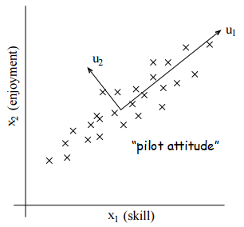

Before we develop the PCA algorithm, we need to do pre-processing to normalize its mean and variance first.

$$Pre\text{-}processing:$$

$$\left.\begin{matrix}1. Set μ=\frac{1}{m}\sum_{i=1}^{m}{x^{\left(i\right)}} \\ 2. Replace x^{\left(i\right)} with x^{\left(i\right)}-μ\end{matrix} \right\} zero out mean$$

$$\begin{matrix}\left.\begin{matrix}3. Set σ_{j}^{2}=\frac{1}{m}\sum_{i=1}^{m}{{\left(x_{j}^{\left(i\right)}\right)}^{2}} \\ 4. Replace x_{j}^{\left(i\right)} with x_{j}^{\left(i\right)}/σ_{j}\end{matrix} \right\} normalize to unit variance of features\end{matrix}$$

In some case, e.g. a grayscale image, which has the same scale of each feature don’t need to do *steps 3-4*.

*Q: How to compute the “major axis of variation”?*

- Finding a unit vector $u$ so that when data is projected onto the direction corresponding to $u$, the variance of the projected points is maximized.

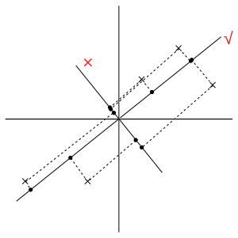

We can describe it in a specific way as follows:

$$If {\left\|u\right\|}_{2}=1, vector x^{(i)} projected on u has length {x^{(i)}}^{T}u.$$

$$Choose u:$$

$$u=\arg{\max_{u: {\left\|u\right\|}_{2}=1}{\frac{1}{m}\sum_{i=1}^{m}{{\left({x^{\left(i\right)}}^{T}u\right)}^{2}}}}$$

$$\begin{matrix}=\arg{\max_{u: {\left\|u\right\|}_{2}=1}{\frac{1}{m}\sum_{i=1}^{m}{\left(u^{T}x^{\left(i\right)}\right)\left({x^{\left(i\right)}}^{T}u\right)}}} \\ =\arg{\max_{u: {\left\|u\right\|}_{2}=1}{u^{T}\left(\frac{1}{m}\sum_{i=1}^{m}{x^{\left(i\right)}{x^{\left(i\right)}}^{T}}\right)u}}\end{matrix}$$

$⇒ u is the principal eigenvector of Σ=\frac{1}{m}\sum_{i=1}^{m}{x^{(i)}{x^{(i)}}^{T}}$

$$\begin{matrix}\max_{u}{ u^{T}Σu} \\ s.t. u^{T}u=1\end{matrix} ⇒ L\left(u,λ\right)=u^{T}Σu-λ\left(u^{T}u-1\right)$$

$$∇_{u}L=2Σu-2λu \underset{→}{set} \vec{0}$$

$$∴ λu=Σu, u is the principal eigenvector of Σ$$

$$Generalize:$$

$$If want k\text{-}dim subspace (k<n),$$

$$choose u_{1},…,u_{k} to be k top eigenvectors of Σ.$$

$$then have x^{(i)}∈R^{n}, new representation of data in \{u_{1},…,u_{k}\} basis:$$

$$y^{\left(i\right)}=\left[ \begin{matrix}\begin{matrix}u_{1}^{T}x^{\left(i\right)} \\ u_{2}^{T}x^{\left(i\right)}\end{matrix} \\ \begin{matrix}⋮ \\ u_{k}^{T}x^{\left(i\right)}\end{matrix}\end{matrix} \right]∈R^{k}$$

Sometimes, the several eigenvalues may be very closed to themselves. And it’s quite dangerous to choose only one or two top eigenvectors to represent it instead of subspace. Because the several “similar” eigenvalues may lead to those associated eigenvectors $u_{i}$ rotate freely within subspaces. Choosing top $k$ eigenvectors (usually contains $≥90\%$ original info) is usually about same.

Here’s another way to explain PCA, trying to minimize the sum of the distance’ squares between each origin data point and accordingly projected point (sum of squares of blue parts).

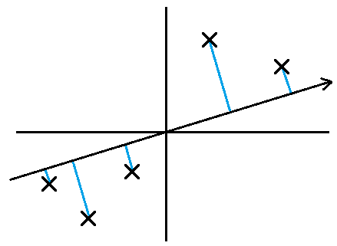

Some applications by PCA:

- Visualization.

To draw pictures of high dimensional data, use PCA to reduce it to 2-d or 3-d.

- Compressor.

Use much lower dimensions to save original main information, without too much loss.

- Learning problems.

1. avoid overfitting, e.g. linear regression; 2. reduce dimensions to simplify the model.

- Anomaly detection.

When a new prediction is quite far away from the subspace in some case.

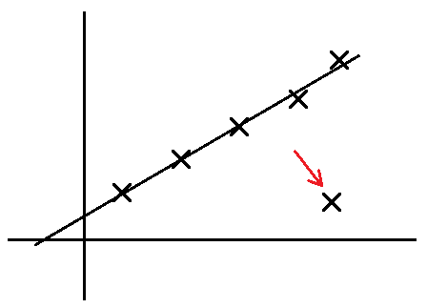

- Matching/distance calculations.

E.g. face detection. When positions of faces vary in different pictures or the origin features almost have 10,000-d.

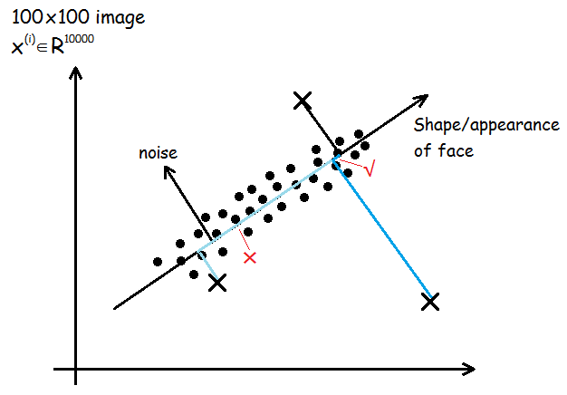

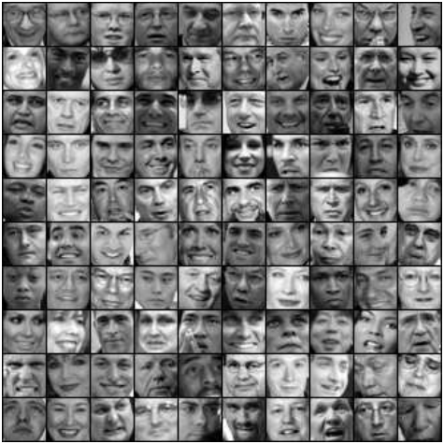 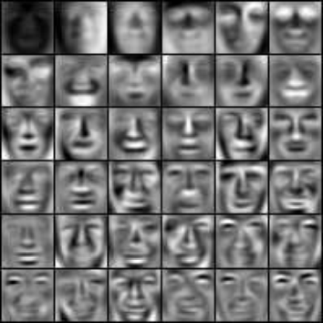

Original faces Eigenfaces

**Lesson 15**

*Outline this Lesson:*

PCA

1. Latent Semantic Indexing (LSI)

2. Singular Value Decomposition (SVD) implementation

ICA

3. Independent Component Analysis (ICA)

① Latent Semantic Indexing (LSI)

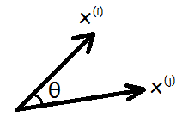Here’s an example. We want to compare lots of text article to find the most similar pairs of them or just scatter them into different clusters by their themes. The first thing we can do is represent all the data set as the vector of a solid vocabulary. Such as:

🡪

Observe the equation above, the numerator of $\operatorname{sim}{(x^{(i)},x^{(j)})}$ actually is

$${x^{\left(i\right)}}^{T}x^{\left(j\right)}=\sum_{k}{x_{k}^{\left(i\right)}x_{k}^{\left(j\right)}}=\sum_{k}{1\left\{Documents i and j both contain word k\right\}}$$

And here comes a problem. When two documents have different words with the same meaning, the $\operatorname{sim}{(x^{(i)},x^{(j)})}$ here must become 0. To avoid this situation, we can apply PCA to project such features into $u_{i}$, and then calculate $\operatorname{sim}{(x^{(i)},x^{(j)})}$. That’s LSI really matters in brief. (E.g. the words “learn” and “study”)

$$x^{\left(i\right)}→"study" x^{\left(j\right)}→"learn"$$

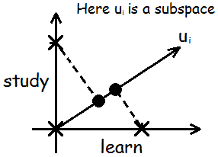

② Singular Value Decomposition (SVD) implementation

When the number of training set features is very large (e.g. $x^{(i)}∈R^{50000}$), the covariance of it ($Σ∈R^{50000×50000}$) may become a very high dimensional matrix, not easily figured out the principle components. One way to solve such a problem is applying SVD to decompose this very large matrix into three matrix product.

$$SVD is known as:$$

$$∀A∈R^{m×n},$$

$$\underset{m×n}{A}=\underset{m×n}{U} \underset{n×n}{D} \underset{n×n}{V^{T}} \left(SVD\right)$$

$$especially,$$

$$D=\operatorname{diag}{σ_{i}}=\left[\begin{matrix}σ_{1} & ⋯ & 0 \\ ⋮ & ⋱ & ⋮ \\ 0 & ⋯ & σ_{n}\end{matrix}\right]$$

$$σ_{i}=singular values of A$$

$$\begin{matrix}U's columns:eigenvetors of AA^{T} \\ V's columns:eigenvetors of A^{T}A\end{matrix}$$

In PCA, we have two ways to implement SVD.

#1 Implement SVD directly to training set (when $n≫m or n≈m$).

$$define$$

$$x^{\left(i\right)}=\left[\begin{matrix}x_{1}^{\left(i\right)} \\ ⋮ \\ \begin{matrix}x_{j}^{\left(i\right)} \\ ⋮ \\ x_{n}^{\left(i\right)}\end{matrix}\end{matrix}\right] X=\left[\begin{matrix}{x^{\left(1\right)}}^{T} \\ ⋮ \\ \begin{matrix}{x^{\left(i\right)}}^{T} \\ ⋮ \\ {x^{\left(m\right)}}^{T}\end{matrix}\end{matrix}\right]$$

$$Σ=\sum_{i=1}^{m}{x^{\left(i\right)}{x^{\left(i\right)}}^{T}}=\left[\begin{matrix}x^{\left(1\right)} & \begin{matrix}⋯ & x^{\left(i\right)} & ⋯\end{matrix} & x^{\left(m\right)}\end{matrix}\right]\left[\begin{matrix}{x^{\left(1\right)}}^{T} \\ ⋮ \\ \begin{matrix}{x^{\left(i\right)}}^{T} \\ ⋮ \\ {x^{\left(m\right)}}^{T}\end{matrix}\end{matrix}\right]=X^{T}X$$

$$To get top k eigenvectors of Σ:$$

$$X=UDV^{T}$$

$$Top k columns of V are top k eigenvectors of X^{T}X=Σ.$$

#2 Implement SVD to $Σ$ (when $m≫n$).

$$To get top k eigenvectors of Σ:$$

$$\left(use the property: Σ is symmetric, U,V are orthogonal matrix\right)$$

$$Σ=UDV^{T}=UDU^{T}=UDU^{-1}$$

$$Top k columns of U are top k eigenvectors of Σ.$$

The last part is some advice and comparisons, when training set satisfies as:

🡪

Here’s a conclusion table of when to use such unsupervised algorithms so far:

|  |  |  |
| --- | --- | --- |
|  | **Model $P\left(x\right)$** | **Not probabilistic** |
| ***“Subspace”*** | Factor Analysis | PCA |
| ***“Clumps”/***  ***“Groups”*** | Mixture of Gaussians | K-means |

③ Independent Component Analysis (ICA)

*Cumulative distribution functions (Cdf)*:

$$random variable s, has density p_{s}\left(s\right). Cdf$$

$$F\left(s\right)=P\left(S≤s\right)=\int_{-∞}^{s}{p_{s}\left(t\right)dt}$$

It means when we specify $p_{s}\left(s\right)$ or $F\left(s\right)$, we can get one with another because

$$p_{s}\left(s\right)=F^{'}\left(s\right)$$

E.g. Gaussian

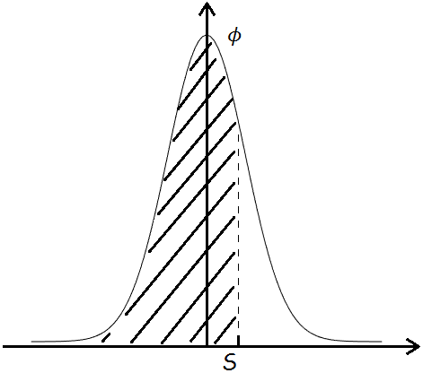 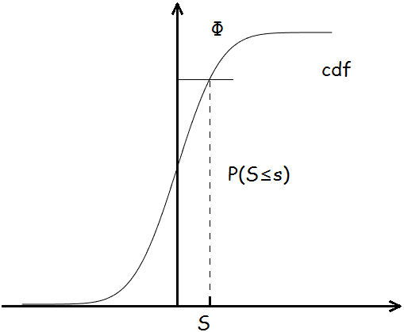

Considering the “cocktail party problem”, here we have $n$ microphones placed in the room to record several $n$ speakers different combinitions of voices. The goal is separating out the original speakers’ speech signals. We can observe:

$$x^{\left(i\right)}=As^{\left(i\right)} x^{\left(i\right)}∈R^{n} (n microphones)$$

$$I.e. x_{j}^{\left(i\right)}=\sum_{k=1}^{n}{A_{jk}s_{k}^{\left(i\right)}}$$

$$purpose:$$

$$Find W=\left[\begin{matrix}—w_{1}^{T}— \\ ⋮ \\ —w_{n}^{T}—\end{matrix}\right]=A^{-1} so that s^{\left(i\right)}=Wx^{\left(i\right)}$$

Here’s some so-called “ICA ambiguities”. E.g. assume $s_{j}^{\left(i\right)} \sim Uniform\left[-1,1\right]$. Because of the symmetry and $s_{j}^{\left(i\right)}-non\text{-}Gaussian$, the scaling (voices volume), permutation (speakers sequence) and the sign of speakers’ voices may vary but finally don’t matter. (If Gaussian, we cannot decompose even one of them because the density is rotationally symmetric.)

$$Let s∈R^{n}.$$

$$Density of s: p_{s}\left(s\right)$$

$$x=As=W^{-1}s, s=Wx$$

$$p_{x}(x)=p_{s}(Wx)·|W|$$

*ICA model*:

$$p\left(s\right)=\prod_{i=1}^{n}{p_{s}\left(s_{i}\right)} choose p_{s}\left(s_{i}\right)$$

$$p\left(x\right)=\prod_{i=1}^{n}{p_{s}\left(w_{i}^{T}x\right)}·\left|W\right|$$

$$\left(where W=A^{-1}=\left[\begin{matrix}—w_{1}^{T}— \\ ⋮ \\ —w_{n}^{T}—\end{matrix}\right], s_{i}=w_{i}^{T}x\right)$$

*Q: How to choose ?*

- E.g. $F\left(s\right)=\frac{1}{1+e^{-s}}, p_{s}\left(s_{i}\right)=F^{'}\left(s_{i}\right)$. We can also use Laplacian $\frac{1}{2}e^{-\left|s\right|}$ or others.

$$Then, given \{x^{(1)},…,x^{(m)}\}:$$

$$l\left(W\right)=\sum_{i}{\log{\prod_{j}{p_{s}\left(w_{j}^{T}x^{\left(i\right)}\right)}·\left|W\right|}}$$

$$=\sum_{i=1}^{m}{\sum_{j=1}^{n}{\log{p_{s}\left(w_{j}^{T}x^{\left(i\right)}\right)}+\log\left|W\right|}}$$

We can implement $g\left(s\right)=\frac{1}{1+e^{-s}}, p_{s}\left(s_{i}\right)=g^{'}\left(s_{i}\right)$, and maximize it via stochastic gradient ascent (or can be transferred to SGD):

$$W≔W+α\left(\left[ \begin{matrix}1-2g\left(w_{1}^{T}x^{\left(i\right)}\right) \\ ⋮ \\ 1-2g\left(w_{n}^{T}x^{\left(i\right)}\right)\end{matrix} \right]{x^{\left(i\right)}}^{T}+{\left(W^{T}\right)}^{-1}\right)$$

Finally, we can get the parameter matrix $W$ (though it’s not very accurate practically, because the truth is $x^{(i)}$ s are dependent) to rebuild the origin unmixed $s^{(i)}$.

$$s^{\left(i\right)}=Wx^{\left(i\right)}$$

PS: Some applications of ICA:

- EEG (Electroencephalogram) data analysis preprocess.

- Small natural image patches (Humanlike recognition).

**Lesson 16**

*Outline this Lesson:*

Reinforcement Learning

1. MDPs (Markov Decision Processes)

2. Value Function

3. Value iteration

4. Policy iteration

① MDPs (Markov Decision Processes)

$“Credit assignment problem”$ (not formal):

Whether we get a positive or negative reward, figure out what we *actually* did right or did wrong to cause the reward, so we can do more of the right things and less of the wrong things.

$$MDP tuple$$

$$\left(S,A,\left\{P_{sa}\right\},γ,R\right) (must all\text{-}known)$$

$\begin{matrix}\begin{matrix} S \text{-} set of states \\ A \text{-} set of actions\end{matrix} \\ \begin{matrix}P_{sa} \text{-} state transition distributions \\ \sum_{s'}{P_{sa}(s')}=1,P_{sa}(s')≥0\end{matrix} \\ \begin{matrix} γ \text{-} discount factor 0≤γ<1 \\ R \text{-} reward function R:S↦R\end{matrix}\end{matrix}$

Here is an example to describe how to model with simplified MDP, not considering $γ$.

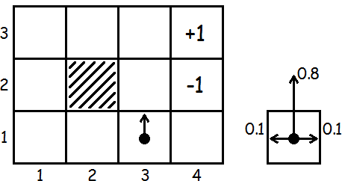

We can know that

$$S: 11 status A=\left\{N,S,E,W\right\}$$

Suppose that when we let the android go north, the probability of going north is just 0.8 along with 0.1 going east or west (assume not stand still), and when it doesn’t move to the final sections, it will take some consumption by -0.02. Then we can write down every element in this step tuple just like

$$\left.\begin{matrix}P_{\left(3,1\right),N}\left(\left(3,2\right)\right)=0.8 \\ \begin{matrix}P_{\left(3,1\right),N}\left(\left(4,1\right)\right)=0.1 \\ P_{\left(3,1\right),N}\left(\left(2,1\right)\right)=0.1\end{matrix} \\ \begin{matrix}P_{\left(3,1\right),N}\left(\left(3,3\right)\right)=0 \\ ⋮\end{matrix}\end{matrix} \right| \begin{matrix}R\left(\left(4,3\right)\right)=+1 \\ R\left(\left(4,2\right)\right)=-1 \\ \begin{matrix}R\left(S\right)=-0.02 \\ for all other status\end{matrix}\end{matrix}$$

$$The dynamics of an MDP proceeds as follows:$$

$$s_{0}\underset{→}{ a_{0} }s_{1}\underset{→}{ a_{1} }s_{2}\underset{→}{ a_{2} }s_{3}\underset{→}{ a_{3} }⋯$$

$$\begin{matrix}\begin{matrix}At state s_{0} \\ Choose a_{1}\end{matrix} \\ \begin{matrix}Get to s_{1} \sim P_{s_{0}a_{0}} \\ Choose a_{1}\end{matrix} \\ \begin{matrix}Get to s_{2} \sim P_{s_{1}a_{1}} \\ ⋮\end{matrix}\end{matrix}$$

$$∴ Total payoff:$$

$$R\left(s_{0}\right)+γR\left(s_{1}\right)+γ^{2}R\left(s_{2}\right)+⋯ (0≤γ<1)$$

$$purpose:$$

$$Choose actions over time \left(a_{0},a_{1},…\right) to maximize$$

$$E\left[R\left(s_{0}\right)+γR\left(s_{1}\right)+γ^{2}R\left(s_{2}\right)+⋯\right]$$

$$Policy π : S↦A$$

*Q: How to understand the meaning of “policy”?*

- E.g. $Optional policy:$

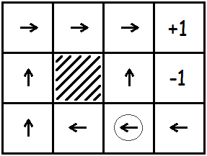

Policy here means a function mapping from the states to the actions. Concretely, we execute some policy $π$ if, whenever we are in state $s$, we take action $a=π(s)$.

② Value Function

$$\left(Define V^{π},V^{*},π^{*} this part.\right)$$

$$value function\left(V^{π} :S↦R\right):$$

$$V^{π}\left(s\right)=E\left[R\left(s_{0}\right)+γR\left(s_{1}\right)+γ^{2}R\left(s_{2}\right)+⋯ | s_{0}=s,π\right]$$

$$V^{π}\left(s\right)=E\left[R\left(s_{0}\right)+γ\left(V^{π}\left(s_{1}\right)\right) | s_{0}=s,π\right]$$

$$Bellman equations:$$

$$\begin{matrix}V^{π}\left(s\right)=R\left(s\right)+γ\sum_{s^{'}∈S}{P_{sπ\left(s\right)}\left(s'\right)V^{π}\left(s'\right)}\end{matrix}$$

$V^{π}\left(s\right)=R\left(s\right)+γE_{s^{'}\sim P_{sπ\left(s\right)}}\left[V^{π}\left(s'\right)\right]$ $(s_{0}→s, s_{1}→s')$

e.g.

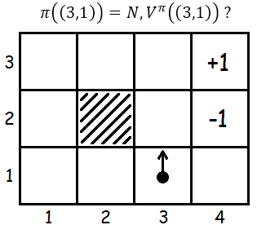

$$V^{π}\left(\left(3,1\right)\right)=R\left(\left(3,1\right)\right)+γ\left[0.8V^{π}\left(\left(3,2\right)\right)+0.1V^{π}\left(\left(4,1\right)\right)+0.1V^{π}\left(\left(2,1\right)\right)\right]$$

$$optimal value function:$$

$$V^{*}\left(s\right)=\max_{π}{V^{π}\left(s\right)}=R\left(s\right)+\max_{a∈A}{γ\sum_{s'∈S}{P_{sa}\left(s'\right)V^{*}\left(s'\right)}}$$

So, we can also have the “*optimal policy” $π^{*}$* :

$$π^{*}\left(s\right)=\arg{\max_{a∈A}{\sum_{s'∈S}{P_{sa}\left(s'\right)V^{*}\left(s'\right)}}}$$

Obviously, we can get the relationships among those 3 functions that

$$V^{*}\left(s\right)=V^{π^{*}}\left(s\right)≥V^{π}\left(s\right)$$

There is one meaningful property that we can use the same policy $π^{*}$ no matter what the initial state of our MDP is!

③ Value iteration

*Value iteration algorithm*:

$\begin{matrix}Assume finite\text{-}state MDPs: \left|S\right|<∞, \left|A\right|<∞. \\ 1. For each state s, initialize V\left(s\right)≔0. \\ \begin{matrix}2. Repeat until convergence: \\ For every state, update \\ V\left(s\right)≔R\left(s\right)+\max_{a∈A}{γ\sum_{s'}{P_{sa}\left(s'\right)V\left(s'\right)}}.\end{matrix}\end{matrix}$

The inner-loop of this algorithm can be updated both in synchronous and asynchronous ways. No matter what the inner loop is actually realized, value iteration will cause $V$ to converge to $V^{*}$, and we can finally find the optimal policy $π^{*}$.

④ Policy iteration

Instead of calculating the optimal value, we can also straightly find an optimal policy for an MDP.

*Policy iteration algorithm*:

$\begin{matrix}Assume finite\text{-}state MDPs: \left|S\right|<∞, \left|A\right|<∞. \\ 1. Initialize π randomly. \\ \begin{matrix}2. Repeat until convergence: \\ i) Let V≔V^{π} (solve Bellman equations). \\ ii) For each state s, let π\left(s\right)≔\arg{\max_{a∈A}{\sum_{s'}{P_{sa}\left(s'\right)V\left(s'\right)}}}.\end{matrix}\end{matrix}$

Both value iteration and policy iteration are standard algorithms for solving MDPs, and there isn’t currently universal agreement over which algorithm is better. However, for MDPs with large state spaces, value iteration maybe preferred. For this reason practically, value iteration seems to be used more often than policy iteration.

*Q: What if we don’t know ?*

- We can estimate them from data via:

$$\begin{matrix}P_{sa}\left(s'\right)=\frac{\#times took action a in s, got to s'}{\#times took action a in s} \\ \left(or \frac{1}{\left|S\right|} if "0/0"\right)\end{matrix}$$

Reinforcement learning problems may have different policies to reach to the final goal. E.g. using value iteration with unknown $P_{sa}$:

$\begin{matrix}1. Initialize π randomly. \\ 2. Repeat: \\ \begin{matrix}\begin{matrix}\left(a\right) Execute π in the MDP for some number of trials. \\ \left(b\right) Update estimates of P_{sa}.\end{matrix} \\ \begin{matrix}\left(c\right) Solve Bellman's equation using value interation to get V. \\ \left(d\right) Update π\left(s\right)≔\arg{\max_{a∈A}{\sum_{s'}{P_{sa}\left(s'\right)V\left(s'\right)}}}.\end{matrix}\end{matrix}\end{matrix}$

**Lesson 17**

*Outline this Lesson:*

Continuous state MDPs

1. Discretization

2. Models/Simulators

3. Fitted value iteration

① Continuous state MDPs: Discretization

In **Lesson 16**, we have focused on the MDPs with a finite number of states. We now need to discuss some algorithms for solving MDPs with an infinite number of states.

E.g.

$$\begin{matrix}Car\left(in 2\text{-}d\right): x,y,θ, \dot{x},\dot{y},\dot{θ} \\ Helicopter\left(in 3\text{-}d\right): x,y,z,ϕ,θ,ψ, \dot{x},\dot{y},\dot{z},\dot{ϕ},\dot{θ},\dot{ψ} \\ Inverted pendulum: x,θ,\dot{x},\dot{θ}\end{matrix}$$

PS: ”*Inverted pendulum*” problem can be shown as picture below, what we’re care about is how to keep dynamic balance of the pole with the little car’s moving controls.

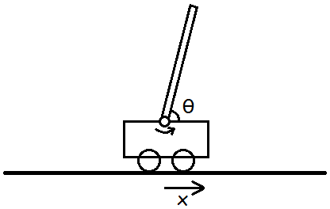

One easy way to solve this kind of problems is to discretize those state space. E.g. we have 2-d states $(s_{1},s_{2})$, we can use a grid to discretize the state space like:

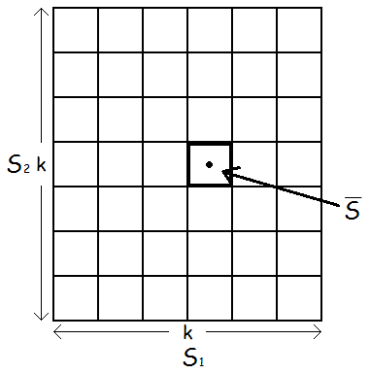

$$\begin{matrix}Discretize into discrete states \overline{s} \\ Solve for V^{*}(\overline{s}), π^{*}(\overline{s})\end{matrix}$$

Here’s two downsides when using this discretization algorithm: $V^{*}$ and $π^{*}$ are assumed fairly naive which means the value function (policy function) is piecewise constant in each of the gridcells.

To better understand such a limitation, we can take a supervised learning problem as an example. Obviously, linear regression would do fine on this problem. However, if we use a representation of discretization intervals, then it’ll look like this:

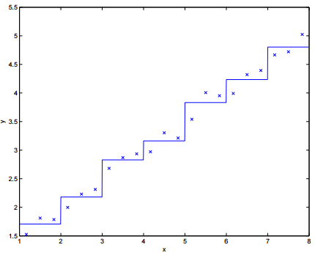

When it happens, we would also need a very fine discretization, which means discretize into very small grid cells, to get a good approximation. Meanwhile, if we do discretize quite much smaller, we can cause another problem called the *curse of dimensionality*.

$$The curse of dimensionality:$$

$$Suppose S=R^{n}, discretize each of the n\text{-}dim states into k values.$$

$$Then the total \# discrete states we have is k^{n}.$$

Owing to this exponential growth, discretization does not scale well to large problems. E.g., with a $10\text{-}d$ continuous state, if we discretize each state variable into $100$ values, we would have ${100}^{10}={10}^{20}$ discrete states, pretty high computational expense!

As a rule of thumb, discretization usually works extremely well for $1\text{-}d$& $2\text{-}d$ problems, along with being simple and quick to implement. $4\text{-}d$& $6\text{-}d$ problems may also works with some extremely careful designs. When $dim\left(states\right)>6$, it will very rarely works to solve the problem.

② Models/Simulators

$$"Continuous S, discrete A."$$

$$Assume we have a model/simulator of MDP as:$$

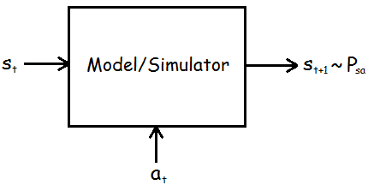

We have several ways to get such a model. One is to use *physics simulation*. Here’s an example of the inverted pendulum mentioned above.

E.g. *physics simulator*

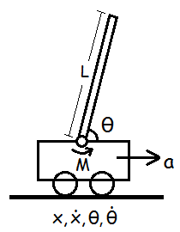

$$s=\left[ \begin{matrix}\begin{matrix}x \\ \dot{x}\end{matrix} \\ \begin{matrix}θ \\ \dot{θ}\end{matrix}\end{matrix} \right]. \dot{s}=\left[ \begin{matrix}\begin{matrix}\dot{x} \\ α-{L·β\cos{θ}}/M\end{matrix} \\ \begin{matrix}\dot{θ} \\ β\end{matrix}\end{matrix} \right], where \begin{matrix}α=\frac{a+L·{\dot{θ}}^{2}\sin{θ}}{M} \\ β=\frac{a+L·{\dot{θ}}^{2}\cos{θ}}{M}\end{matrix}$$

$$s_{t+1}=s_{t}+∆t·\left[ \begin{matrix}\begin{matrix}\dot{x} \\ α-{L·β\cos{θ}}/M\end{matrix} \\ \begin{matrix}\dot{θ} \\ β\end{matrix}\end{matrix} \right], ∆t=0.1 seconds$$

We can easily get $P_{sa}$, then the other parameters can come out naturally.

An alternative way to get a model is to *learn a model* from data straightly. Suppose we execute $m$**trials** in which we repeatedly take actions in an MDP, each trial for $T$ timesteps.

The $m$ state sequences like the following:

$$\begin{matrix}\begin{matrix}s_{0}^{(1)}\underset{→}{ a_{0}^{(1)} }s_{1}^{(1)}\underset{→}{ a_{1}^{(1)} }s_{2}^{(1)}\underset{→}{ a_{2}^{(1)} }⋯\underset{→}{ a_{T-1}^{(1)} }s_{T}^{(1)} \\ s_{0}^{(2)}\underset{→}{ a_{0}^{(2)} }s_{1}^{(2)}\underset{→}{ a_{1}^{(2)} }s_{2}^{(2)}\underset{→}{ a_{2}^{(2)} }⋯\underset{→}{ a_{T-1}^{(2)} }s_{T}^{(2)}\end{matrix} \\ \begin{matrix}⋯ \\ s_{0}^{(m)}\underset{→}{ a_{0}^{(m)} }s_{1}^{(m)}\underset{→}{ a_{1}^{(m)} }s_{2}^{(m)}\underset{→}{ a_{2}^{(m)} }⋯\underset{→}{ a_{T-1}^{(m)} }s_{T}^{(m)}\end{matrix}\end{matrix}$$

We can use learning algorithm to estimate $s_{t+1}$ as a **function** of $s_{t}, a_{t}$.

E.g.

$$Assume$$

$$s_{t+1}=As_{t}+Ba_{t} (A∈R^{n×n}, B∈R^{n})$$

$$purpose:$$

$$\arg{\min_{A, B}{\sum_{i=1}^{m}{\sum_{t=0}^{T-1}{{\left\|s_{t+1}^{(i)}-(As_{t}^{(i)}+Ba_{t}^{(i)})\right\|}^{2}}}}}$$

Here we can use both *deterministic* model and *stochastic* model as follows:

$$\begin{matrix}s_{t+1}=As_{t}+Ba_{t} (deterministic) \\ or \\ \begin{matrix}s_{t+1}=As_{t}+Ba_{t}+ε_{t} (stochastic) \\ ε_{t} \sim N(0,Σ)\end{matrix}\end{matrix}$$

*Q: Non-linear model?*

- $“Choose feature ϕ(s) of state s”.$

$$Approximate:$$

$$V(s)=θ^{T}ϕ(s) ↔ "h_{θ}(x)=θ^{T}ϕ(x)"$$

③ Fitted value iteration

Recall the discrete value iteration, we would like to perform the update here as:

$$\begin{matrix}V\left(s\right)≔R\left(s\right)+γ\max_{a}{\int_{s^{'}}{P_{sa}\left(s^{'}\right)V(s^{'})ds^{'}}} \\ =R\left(s\right)+γ\max_{a}{E_{s^{'}\sim P_{sa}}\left[V(s^{'})\right]}\end{matrix}$$

$$Fitted value iteration algorithm (linear regression type):$$

$\begin{matrix}\begin{matrix}1. Randomly sample m states \{s^{(1)},s^{(2)},{…,s}^{(m)}\}⊆S. \\ 2. Initialize θ≔0.\end{matrix} \\ \begin{matrix}3. Repeat: \\ \begin{matrix}For i=1,…,m \\ \begin{matrix}\begin{matrix}For each action a∈A \\ \begin{matrix}Sample s_{1}^{'},…,s_{k}^{'} \sim P_{s^{\left(i\right)}a} (using a model of the MDP). \\ Let q(a)=\frac{1}{k}\sum_{j=1}^{k}{R(s^{(i)})+γV(s_{j}^{'})} \\ //estimate for R(s^{\left(i\right)})+γE_{s^{'}\sim P_{s^{(i)}a}}[V(s^{'})].\end{matrix}\end{matrix} \\ \begin{matrix}Set y^{(i)}=\max_{a}{q(a)}. \\ //estimate for R(s^{\left(i\right)})+γ\max_{a}{E_{s^{'}\sim P_{s^{(i)}a}}[V(s^{'})]}.\end{matrix}\end{matrix} \\ \begin{matrix}//Want: V(s^{\left(i\right)})≈y^{(i)}. \\ θ≔\arg{\min_{θ}{\frac{1}{2}\sum_{i=1}^{m}{{(θ^{T}ϕ(s^{\left(i\right)})-y^{(i)})}^{2}}}}\end{matrix}\end{matrix}\end{matrix}\end{matrix}$

In this algorithm, we just assume $s$ satisfies stochastic model. When using deterministic model, we can simplify it by setting the parameter $k$ to be equal to 1.

*Q: How to get the action ?*

- Because of the continuous states and the discrete actions, we just take action at some specific states by

$$π^{*}\left(s\right)=a=\arg{\max_{a}{E_{s^{'}\sim P_{sa}}[V(s^{'})]}}$$

$E_{s^{'}\sim P_{sa}}\left[V\left(s^{'}\right)\right]$ may hardly come out in some case when we have to sample state $S$. We can apply the approximation when the simulator satisfies some deterministic type, i.e. $s_{t+1}=f\left(s_{t},a_{t}\right)+ε_{t}$, $f$ is a deterministic function such as $f\left(s_{t},a_{t}\right)=As_{t}+Ba_{t}$ and $ε_{t} \sim N(0,Σ)$ or $ε_{t}=0$ using the approximation

$$\begin{matrix}E_{s^{'}}[V(s^{'})]≈V(E_{s^{'}}\left[s^{'}\right]) \\ =V(f(s,a))\end{matrix}$$

then choose action

$$\arg{\max_{a}{V(f(s,a))}}$$

**Lesson 18**

*Outline this Lesson:*

1. State-action rewards

2. Finite horizon MDPs

3. Linear dynamical systems: Models

4. Linear Quadratic Regulation (LQR)

5. Riccati equation

① State-action rewards

General (discrete) MDPs:

$$MDP:\left(S,A,\left\{P_{sa}\right\},γ,R\right)$$

$$0≤γ<1, R:S↦R$$

$$\begin{matrix}\begin{matrix}V\left(s\right)≔R\left(s\right)+\max_{a∈A}{γ\sum_{s^{'}∈S}{P_{sa}\left(s^{'}\right)V\left(s^{'}\right)}}(converge to V^{*}) \\ =R\left(s\right)+γ\max_{a∈A}{E_{s^{'}\sim P_{sa}}\left[V(s^{'})\right]}\end{matrix} \\ \begin{matrix}π^{*}\left(s\right)=\arg{\max_{a∈A}{\sum_{s'∈S}{P_{sa}\left(s'\right)V^{*}\left(s'\right)}}} \\ =\arg{\max_{a∈A}{E_{s^{'}\sim P_{sa}}\left[V^{*}(s^{'})\right]}}\end{matrix}\end{matrix}$$

Here the expectation part means estimating the next state by the distribution $P_{sa}$. And we have a more general setting to fit continuous MDPs precisely, we need to apply some variation of previous assumptions.

$$State\text{-}action rewards \left(Q\text{-}learning\right):$$

$$R: S×A↦R$$

$$Total payoff:$$

$$R\left(s_{0},a_{0}\right)+γR\left(s_{1},a_{1}\right)+γ^{2}R\left(s_{2},a_{2}\right)+⋯$$

$$Value \& policy:$$

$\begin{matrix}V^{*}\left(s\right)=\max_{a∈A}{R\left(s,a\right)+γE_{s^{'}\sim P_{sa}}\left[V^{*}(s^{'})\right]} \\ V\left(s\right)≔\max_{a∈A}{R\left(s,a\right)+γE_{s^{'}\sim P_{sa}}\left[V\left(s^{'}\right)\right]} \\ π^{*}\left(s\right)=\arg{\max_{a∈A}{R\left(s,a\right)+γE_{s^{'}\sim P_{sa}}\left[V^{*}(s^{'})\right]}}\end{matrix}$

② Finite horizon MDPs

$$Finite horizon MDPs: (S,A,\{P_{sa}^{(t)}\},T,R) (T=horizon time)$$

$$Total payoff:$$

$$R^{\left(0\right)}\left(s_{0},a_{0}\right)+R^{\left(1\right)}\left(s_{1},a_{1}\right)+⋯+R^{\left(T\right)}\left(s_{T},a_{T}\right)$$

$$Optimal policy π^{(t)} : S↦A (non\text{-}stationary)$$

$$Time dependent dynamics:$$

$$s_{t+1}∼P_{s_{t},a_{t}}^{(t)}$$

*Q: Why here the optimal policy happen to be non-stationary?*

- E.g.

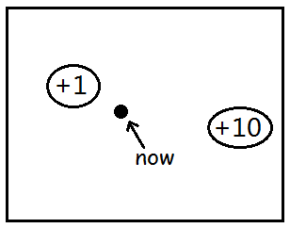

As the cartoon shown above, we want to take actions to aim for the +10 goal at the very beginning. However, when we don’t have enough time steps left to reach the +10 goal along with a closer +1 goal, choose the latter is better.

③ Linear dynamical systems: Models

$$\begin{matrix}V_{t}^{*}\left(s\right)=E\left[R^{\left(t\right)}\left(s_{t},a_{t}\right)+⋯+R^{\left(T\right)}\left(s_{T},a_{T}\right) | s_{t}=s,π^{*}\right]\end{matrix}$$

$$∀s∈S : V_{T}^{*}\left(s\right)≔\max_{a∈A}{R^{\left(T\right)}\left(s,a\right)} (1)$$

$$∀t<T : V_{t}^{*}\left(s\right)≔\max_{a∈A}{R^{\left(t\right)}\left(s,a\right)+E_{s^{'}\sim P_{sa}^{\left(t\right)}}\left[V_{t+1}^{*}\left(s^{'}\right)\right]} (2)$$

$$π_{t}^{*}\left(s\right)≔\arg{\max_{a∈A}{R^{(t)}\left(s,a\right)+E_{s^{'}\sim P_{sa}^{\left(t\right)}}\left[V_{t+1}^{*}\left(s^{'}\right)\right]}}$$

We can calculate every value and policy sequence with *dynamic programming* like:

$$\begin{matrix}V_{T}^{*}, V_{T-1}^{*}, V_{T-2}^{*}, …, V_{0}^{*} \\ π_{T}^{*}, ………… , π_{0}^{*}\end{matrix}$$

$$Dynamic Programming algorithm:$$

$$\begin{matrix}1. Compute V_{T}^{*} using eq. (1). \\ \begin{matrix}2. For t=T-1,…,0: \\ compute V_{t}^{*} with V_{t+1}^{*} using eq. (2)\end{matrix}\end{matrix}$$

$$Linear model$$

$$s_{t+1} \sim P_{s_{t},a_{t}}=As_{t}+Ba_{t}$$

$$\begin{matrix}s_{0}^{(1)}\underset{→}{ a_{0}^{(1)} }s_{1}^{(1)}\underset{→}{ a_{1}^{(1)} }⋯\underset{→}{ a_{T-1}^{(1)} }s_{T}^{(1)} \\ \begin{matrix} ⋮ \\ s_{0}^{(m)}\underset{→}{ a_{0}^{(m)} }s_{1}^{(m)}\underset{→}{ a_{1}^{(m)} }⋯\underset{→}{ a_{T-1}^{(m)} }s_{T}^{(m)}\end{matrix}\end{matrix}$$

$$\arg{\min_{A,B}{\frac{1}{2}\sum_{i=1}^{m}{\sum_{t=1}^{T-1}{{\left\|s_{t+1}-\left(As_{t}+Ba_{t}\right)\right\|}^{2}}}}}$$

$$Linearize a non\text{-}linear model:$$

$$s_{t+1}=f\left(s_{t},a_{t}\right)$$

E.g. inverted pendulum

$$\left( \begin{matrix}\begin{matrix}x_{t+1} \\ {\dot{x}}_{t+1}\end{matrix} \\ \begin{matrix}θ_{t+1} \\ {\dot{θ}}_{t+1}\end{matrix}\end{matrix} \right)=f\left( \begin{matrix}\begin{matrix}x_{t} \\ {\dot{x}}_{t}\end{matrix} \\ \begin{matrix}θ_{t} \\ {\dot{θ}}_{t}\end{matrix}\end{matrix} ,a_{t}\right)$$

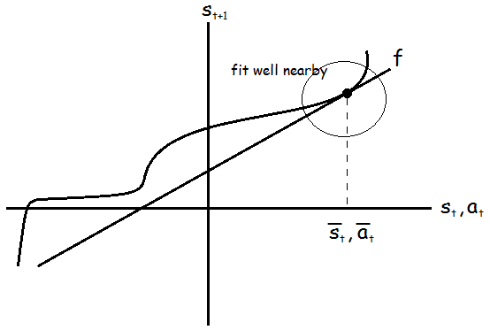

$$s_{t+1}≈f\left({\overline{s}}_{t},{\overline{a}}_{t}\right)+{\left(∇_{s}f\right)}^{T}\left(s_{t}-{\overline{s}}_{t}\right)+{\left(∇_{a}f\right)}^{T}\left(a_{t}-{\overline{a}}_{t}\right)$$

*Q: How to solve the problem if $s_{t+1}$ has a constant?*

- *Let $s_{t}^{'}={\left(1,s_{t}^{T}\right)}^{T}$*.

④ Linear Quadratic Regulation (LQR)

$$(S,A,\{P_{sa}^{(t)}\},T,R) S=R^{n}, A=R^{d}$$

$$\begin{matrix}P_{sa}^{(t)}: s_{t+1}=A_{t}s_{t}+B_{t}a_{t}+w_{t} \\ \begin{matrix}A_{t}∈R^{n×n}, B_{t}∈R^{n×d} \\ w_{t} \sim N\left(0,Σ_{t}\right), not very important\end{matrix}\end{matrix}$$

$$Quadratic rewards:$$

$$\begin{matrix}R^{\left(t\right)}\left(s_{t},a_{t}\right)=-s_{t}^{T}U_{t}s_{t}-a_{t}^{T}W_{t}a_{t} \\ \begin{matrix}U_{t}∈R^{n×n}, W_{t}∈R^{d×d} \\ U_{t}≥0,W_{t}≥0 (semi\text{-}pd)\end{matrix}\end{matrix}$$

$$∴ s_{t}^{T}U_{t}s_{t}≥0, { a}_{t}^{T}W_{t}a_{t}≥0 ⇒ R^{\left(t\right)}\left(s_{t},a_{t}\right)≤0$$

E.g. Helicopter control

$$Want s_{t}≈0. Choose U_{t}=I, W_{t}=I.$$

$$∴ R^{\left(t\right)}\left(s_{t},a_{t}\right)=-s_{t}^{T}s_{t}-a_{t}^{T}a_{t}=-{\left\|s_{t}\right\|}^{2}-{\left\|a_{t}\right\|}^{2}$$

To simplify this model, we can also suppose that

$$\begin{matrix}A=A_{1}=A_{2}=… \\ B=B_{1}=B_{2}=…\end{matrix}$$

$$purpose:$$

$$\max{R^{\left(0\right)}\left(s_{0},a_{0}\right)+R^{\left(1\right)}\left(s_{1},a_{1}\right)+…+R^{\left(T\right)}\left(s_{T},a_{T}\right)}$$

$$V_{T}^{*}\left(s_{T}\right)=\max_{a_{T}}{R^{\left(T\right)}\left(s_{T},a_{T}\right)}$$

$$\begin{matrix}=\max_{a_{T}}{-s_{T}^{T}U_{T}s_{T}-a_{T}^{T}W_{T}a_{T}} \\ =-s_{T}^{T}U_{T}s_{T} (a_{T}^{T}W_{T}a_{T}≥0)\end{matrix}$$

$$π_{T}^{*}\left(s_{T}\right)=\arg{\max_{a_{T}}{R^{\left(T\right)}\left(s_{T},a_{T}\right)}}=0$$

$$V_{t+1}^{*}⇝V_{t}^{*}:$$

$$Suppose$$

$$\begin{matrix}V_{t+1}^{*}\left(s_{t+1}\right)=s_{t+1}^{T}ϕ_{t+1}s_{t+1}+ψ_{t+1} \\ (ϕ_{t+1}∈R^{m×n}, ψ_{t+1}∈R)\end{matrix}$$

$$Then for some ϕ_{t}, ψ_{t}$$

$$V_{t}^{*}\left(s_{t}\right)=s_{t}^{T}ϕ_{t}s_{t}+ψ_{t}$$

$$V_{T}^{*}\left(s_{T}\right)=-s_{T}^{T}U_{T}s_{T}=s_{T}^{T}ϕ_{T}s_{T}+ψ_{T} (ϕ_{T}(1)=-U_{T}, ψ_{T}=0)$$

$$\begin{matrix}V_{t}^{*}\left(s_{t}\right)=s_{t}^{T}ϕ_{t}s_{t}+ψ_{t} (3) \\ \begin{matrix}=\max_{a_{t}}{R^{\left(t\right)}\left(s_{t},a_{t}\right)+E_{s_{t+1}\sim P_{s_{t}{,a}_{t}}^{\left(t\right)}}\left[V_{t+1}^{*}\left(s_{t+1}\right)\right]} \\ =\max_{a_{t}}{-s_{t}^{T}U_{t}s_{t}-a_{t}^{T}W_{t}a_{t}+E_{s_{t+1}\sim N(A_{t}s_{t}+B_{t}a_{t}, Σ_{t})}\left[s_{t+1}^{T}ϕ_{t+1}s_{t+1}+ψ_{t+1}\right]}\end{matrix} \\ \begin{matrix}=\max_{a_{t}}{-s_{t}^{T}U_{t}s_{t}-a_{t}^{T}W_{t}a_{t}+ψ_{t+1}+\operatorname{tr}{(Σ_{t}ϕ_{t+1})}+{{(A}_{t}s_{t}+B_{t}a_{t})}^{T}ϕ_{t+1}{(A}_{t}s_{t}+B_{t}a_{t})} \\ =\max_{a_{t}}{-a_{t}^{T}W_{t}a_{t}+{{(A}_{t}s_{t}+B_{t}a_{t})}^{T}ϕ_{t+1}{(A}_{t}s_{t}+B_{t}a_{t})}\end{matrix}\end{matrix}$$

$$∴ a_{t}=π_{t}^{*}\left(s_{t}\right)=-{\left(B_{t}^{T}ϕ_{t+1}B_{t}-W_{t}\right)}^{-1}B_{t}^{T}ϕ_{t+1}A_{t}·s_{t}=L_{t}s_{t} (4)$$

⑤ Riccati equation

Using $eq. (3) (4)$, we can finally get the *Discrete Ricatti equations*:

$$\begin{matrix}ϕ_{t}=A_{t}^{T}\left[ϕ_{t+1}-ϕ_{t+1}B_{t}{\left(B_{t}^{T}ϕ_{t+1}B_{t}-W_{t}\right)}^{-1}B_{t}^{T}ϕ_{t+1}\right]A_{t}-U_{t} \\ ψ_{t}=\operatorname{tr}\left(Σ_{t}ϕ_{t+1}\right)+ψ_{t+1}\end{matrix}$$

$$To summarize, the algorithm work as follows:$$

$$\begin{matrix}\begin{matrix}1. (If necessary) Estimate parameters A_{t},B_{t},Σ_{t}. \\ 2. Initialize ϕ_{T}≔-U_{T}, ψ_{T}≔0.\end{matrix} \\ \begin{matrix}3. Iterate from t=T-1,…,0 to update ϕ_{t},ψ_{t} using ϕ_{t+1},ψ_{t+1}. \\ \begin{matrix}Compute L_{t} using ϕ_{t+1},ψ_{t+1} using eq. (4) \\ π_{t}^{*}\left(s_{t}\right)=L_{t}s_{t}.\end{matrix}\end{matrix}\end{matrix}$$

If we just need to figure out the optimal policy, we can run this algorithm just to update only $ϕ_{t}$!

**Lesson 19**

*Outline this Lesson:*

1. Debugging RL algorithms

2. LQR - Differential dynamic programming (DDP)

3. Kalman filter & Linear Quadratic Gaussian (LQG)

① Debugging RL algorithms

This example we have talked about in **Lesson 11**, here we pay attention to the analysis of such a problem rather than diagnostics before.



Build a simulator of helicopter 🡪 Choose a cost function🡪 minimize $J\left(θ\right)$ to get $θ_{RL}$

$$Say$$

$$\begin{matrix}\begin{matrix}J\left(θ\right)={\left\|x-x_{desired}\right\|}^{2} x \text{-} helicopter position \\ θ_{RL}=\arg{\min_{θ}{J\left(θ\right)}}\end{matrix}\end{matrix}$$

Suppose the resulting controller parameters gives much worse performance than human pilot. *What to do next?*

- Improve simulator?

- Modify cost function?

- Modify RL algorithm?

*

Diagnostics:

- Ifflies well in simulation, but not in reality. 🡪 Problem in simulation.

Letbe the human control policy.

- If, cost function is failed to minimize. 🡪 Problem in RL algorithm.

- If $J\left(θ_{human}\right)≥J\left(θ_{RL}\right)$, it means that minimizing $J$ doesn’t correspond to good autonomous flight. 🡪 Problem in cost function.

② LQR - Differential dynamic programming (DDP)

$$DDP algorithm:$$

$$\begin{matrix}s_{t+1}=f\left(s_{t},a_{t}\right), non\text{-}linear, deterministic. \\ (must given first!)\end{matrix}$$

$$\begin{matrix}\begin{matrix}\begin{matrix}1. Come up with nomial trajectory with \\ {\overline{s}}_{0},{\overline{a}}_{0}→{\overline{s}}_{1},{\overline{a}}_{1}→…→{\overline{s}}_{T},{\overline{a}}_{T}.\end{matrix} \\ \begin{matrix}2. Linearize f around each trajectory point, \\ \begin{matrix} i.e. s_{t+1}≈f\left({\overline{s}}_{t},{\overline{a}}_{t}\right)+\left(∇_{s}f\left({\overline{s}}_{t},{\overline{a}}_{t}\right)\right)\left(s_{t}-{\overline{s}}_{t}\right)+\left(∇_{a}f\left({\overline{s}}_{t},{\overline{a}}_{t}\right)\right)\left(a_{t}-{\overline{a}}_{t}\right) \\ =A_{t}s_{t}+B_{t}a_{t} \\ Expect \left(s_{t},a_{t}\right)≈\left({\overline{s}}_{t},{\overline{a}}_{t}\right).\end{matrix}\end{matrix}\end{matrix} \\ \begin{matrix}3. Use LQR to get π_{t}. \\ \begin{matrix}\begin{matrix}4. Use new policy π_{t} to get new nomial trajectory, \\ \begin{matrix}\begin{matrix} i.e. {\overline{s}}_{0}=initial state \\ {\overline{a}}_{t}=π_{t}\left({\overline{s}}_{t}\right) \\ {\overline{s}}_{t+1}=f\left({\overline{s}}_{t},{\overline{a}}_{t}\right)\end{matrix} \\ get {\overline{s}}_{0},π_{0}\left({\overline{s}}_{0}\right)→{\overline{s}}_{1},π_{1}\left({\overline{s}}_{1}\right)→…→{\overline{s}}_{T},π_{T}\left({\overline{s}}_{T}\right)\end{matrix}\end{matrix} \\ linearize around new trajectory and repeat.\end{matrix}\end{matrix}\end{matrix}$$

The generate steps can be described as:

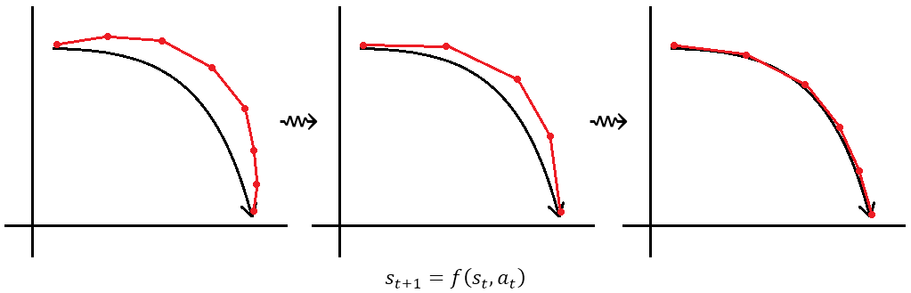

Here we just give out the steps of the algorithm, and we will discuss the exact example in the next lesson.

③ Kalman filter & Linear Quadratic Gaussian (LQG)

In the real world, we can hardly observe the full state $s_{t}$, we just observe the partial state. To solve such a problem, we have a new model called *POMDP* (Partially Observable MDPs). In this case, we cannot straightly get current state $s_{t}$, but with the observation $o_{t}$, we can indirectly get it by:

$$o_{t}|s_{t} \sim O\left(o | s\right)$$

Meanwhile, the tuple of a finite-horizon POMDP is

$$(S,Y,\left\{O_{s}\right\},A,\{P_{sa}\},T,R)$$

In this section, we can get the LQG, which is a special type of LQR through the following assumptions ($y_{t}$ is the observation of the *belief state $s_{t}, y_{t}∈R^{m}, m<n$*):

$$\left\{\begin{aligned}s_{t+1}=As_{t}+w_{t}, w_{t} \sim N(0,Σ_{w}) \\ y_{t}=Cs_{t}+v_{t}, v_{t} \sim N(0,Σ_{v})\end{aligned}\right.$$

$Want:$ $P\left(s_{t} | y_{1},…,y_{t}\right)$

$$s_{0},s_{1},…,s_{t},y_{1},…,y_{t} have a joint Gaussian distribution$$

$$\left[ \begin{matrix}\begin{matrix}s_{0} \\ ⋮ \\ s_{t}\end{matrix} \\ \begin{matrix}y_{1} \\ ⋮ \\ y_{t}\end{matrix}\end{matrix} \right] \sim N\left(μ,Σ\right) for some μ,Σ$$

Using the marginal formulas of Gaussians, we would get (theoretically)

$$s_{t}|y_{1},…,y_{t} \sim N\left(s_{t|t},Σ_{t|t}\right)$$

Unfortunately, the matrices of the marginal distribution always change in time! When time goes, the final matrices will be computationally expensive, about a cost in $O\left(t^{3}\right)$! To avoid this situation, we use the *Kalman filter* algorithm.

$$Outline:$$

$$\begin{matrix}P\left(s_{t} | y_{1},…,y_{t}\right) \\ \begin{matrix}\begin{matrix}↓ predict \\ P\left(s_{t+1} | y_{1},…,y_{t}\right)\end{matrix} \\ \begin{matrix}↓ update \\ P\left(s_{t+1} | y_{1},…,y_{t+1}\right)\end{matrix}\end{matrix}\end{matrix}$$

$$Predict step:$$

$$s_{t}|y_{1},…,y_{t} \sim N\left(s_{t|t},Σ_{t|t}\right)$$

$$then$$

$$s_{t+1}|y_{1},…,y_{t} \sim N\left(s_{t+1|t},Σ_{t+1|t}\right)$$

$$where$$

$$\begin{matrix} s_{t+1|t}=As_{t|t} \\ Σ_{t+1|t}=AΣ_{t|t}A^{T}+Σ_{s}\end{matrix}$$

$$Update step:$$

$$get$$

$$s_{t}|y_{1},…,y_{t} \sim N\left(s_{t+1|t+1},Σ_{t+1|t+1}\right)$$

$$where$$

$$\begin{matrix} s_{t+1|t+1}=s_{t+1|t}+K_{t+1}\left(y_{t+1}-Cs_{t+1|t}\right) \\ Σ_{t+1|t+1}=Σ_{t+1|t}-K_{t+1}CΣ_{t+1|t} \\ K_{t+1}≔Σ_{t+1|t}C^{T}{\left(CΣ_{t+1|t}C^{T}+Σ_{y}\right)}^{-1}\end{matrix}$$

So, $s_{t+1|t+1}$ is the “best” estimate for ${ s}_{t+1}$.

Through this algorithm, we can obviously figure out that we don’t need to calculate the former $t$ time steps! The update steps only depends on the previous distribution.

To put it all together, algorithm first runs a *forward pass* to compute the $K_{t}, Σ_{t|t}, s_{t|t}$. Then it runs a *backward pass* (LQR updates) to compute $ϕ_{t}, ψ_{t}, L_{t}$. Finally, we can get the optimal policy $a_{t}=L_{t}s_{t|t}$.

**Lesson 20**

*Outline this Lesson:*

1. POMDPs (Partially Observable MDPs)

2. Policy search

3. Conclusion

① POMDPs (Partially Observable MDPs)

$$The tuple of POMDP:$$

$$\begin{matrix}(S,A,Y,\{P_{sa}\},\left\{O_{s}\right\},T,R) \\ \begin{matrix} Y-set of possible observations \\ O_{s}-observation distributions\end{matrix}\end{matrix}$$

$At each step, observe$ $y_{t} \sim O_{s_{t}} (if in state s_{t})$

② Policy search

$$Define a set Π of policies, search for a good π∈Π. (like define a$$

$$set H of hypothesis, search for a good h∈H)$$

(1) Reinforced

$$New definition:$$

$$A stochastic policy is a function π: S×A↦R where π\left(s,a\right) (now$$

$$Q(s,a)) is probability of taking action a in state s.$$

$\left( \sum_{a}{π(s,a)}=1, π(s,a)≥0\right)$

E.g. An inverted pendulum system just like

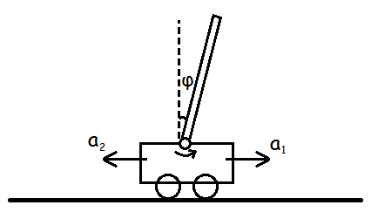

$$Assume$$

$$\begin{matrix}π_{θ}\left(s,a_{1}\right)=\frac{1}{1+e^{-θ^{T}s}} \\ π_{θ}\left(s,a_{2}\right)=1-\frac{1}{1+e^{-θ^{T}s}}\end{matrix}$$

$$s=\left[ \begin{matrix}1 \\ \begin{matrix}x \\ \dot{x}\end{matrix} \\ \begin{matrix}ϕ \\ \dot{ϕ}\end{matrix}\end{matrix} \right], θ=\left[ \begin{matrix}0 \\ \begin{matrix}0 \\ 0\end{matrix} \\ \begin{matrix}1 \\ 0\end{matrix}\end{matrix} \right]$$

$$P\left("a=right"\right)=\frac{1}{1+e^{-θ^{T}s}}-\frac{1}{1+e^{-ϕ}}$$

$$purpose:$$

$$\max_{θ}{E\left[R\left(s_{0},a_{0}\right)+…+R\left(s_{T},a_{T}\right) | π_{θ},s_{0}\right]}$$

$$\begin{matrix}E\left[R\left(s_{0},a_{0}\right)+…+R\left(s_{T},a_{T}\right) | π_{θ},s_{0}\right]\end{matrix}$$

$\begin{matrix}=\sum{P\left(s_{0},a_{0},s_{1},a_{1},…,s_{T},a_{T}\right)\left[R\left(s_{0},a_{0}\right)+…+R\left(s_{T},a_{T}\right)\right]} \\ =\sum{P\left(s_{0}\right)π_{θ}\left(s_{0},a_{0}\right)P_{s_{0}a_{0}}\left(s_{1}\right)π_{θ}\left(s_{1},a_{1}\right)·⋯·π_{θ}\left(s_{T},a_{T}\right)×"payoff"}\end{matrix}$

$$\left(payoff= R\left(s_{0},a_{0}\right)+…+R\left(s_{T},a_{T}\right)\right)$$

So the *reinforced algorithm* (gradient ascend):

$$Loop until convergence:$$

$$\begin{matrix}1. Sample s_{0},a_{0},s_{1},a_{1},…,s_{T},a_{T}. \\ 2. Compute payoff=R\left(s_{0},a_{0}\right)+…+R\left(s_{T},a_{T}\right). \\ \begin{matrix}3. Update \\ θ≔θ+α·\left[\frac{∇_{θ}π_{θ}\left(s_{0},a_{0}\right)}{π_{θ}\left(s_{0},a_{0}\right)}+…+\frac{∇_{θ}π_{θ}\left(s_{T},a_{T}\right)}{π_{θ}\left(s_{T},a_{T}\right)}\right]×payoff.\end{matrix}\end{matrix}$$

If we only have an approximation $\hat{s}$ of $s$ (could be $\hat{s}=s_{t|t}$ from Kalman Filter), we can also use it with just a little variation:

$$π_{θ}\left(\hat{s},a\right)=\frac{1}{1+e^{-θ^{T}\hat{s}}} (or other model)$$

As a gradient ascend algorithm, the reinforced also has the negative property such as: Because of the observed noise, the sampled sequence in essentially a sort of random direction, only satisfy the expectation; As the parameter $T$ grows and the noise, it may take a lot of time to sample the different sequence (see the pseudocode), converge with million iteration step etc.

This algorithm is more useful in just simulator rather than the actual physical device. So, we have another algorithm called *PEGASUS* to simplify it.

(2) PEGASUS (Policy Evaluation of Gradient And Search Using Scenarios)

This algorithm totally based on the inspiration of simulator way to build models (rather than sample the physical data). The core method is using a random number generator ***only once*** to generate the stochastic sequence. Then fix it in advance and always use the same sequence of random numbers.

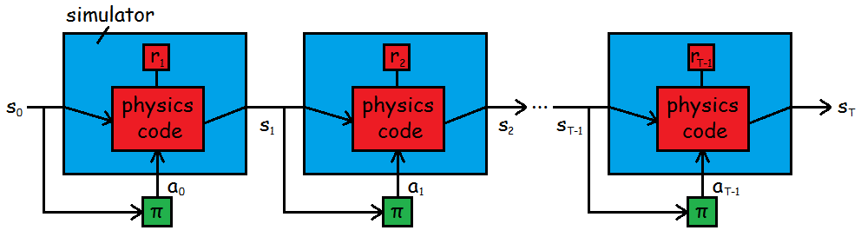

$$Solution: Using PEGASUS method, we can turn problem into an ordinary$$

$$deterministic optimization problem.$$

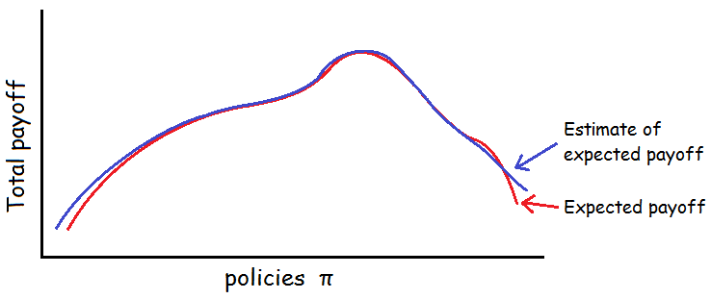

③ Conclusion

*Policy search* algorithms are easier to the low level control tasks (just like reflexes), such as helicopter flight, driving or controlling various robots.

Problems of long path plannings (like chess, Tetris etc.) prefer to apply a *value function* method instead.

The key of RL problems is really *sequential decision making*, which means we need to make decisions step by step, and each step may have long-term consequences.

$$Associated course finally:$$

$$\begin{matrix}\begin{matrix}CS221 \\ \begin{matrix}CS223A CS225A CS225B \\ CS222 CS227 \end{matrix} \\ \begin{matrix}CS228 \\ EE364A \end{matrix}\end{matrix} & \begin{matrix}\text{-} an overview of AI via Andrew Ng \\ \begin{matrix}\text{-} robotics class \\ \text{-} knowledge representation and reasoning class\end{matrix} \\ \begin{matrix}\text{-} Probabilistic Graphical Models \\ \text{-} Convex Optimization\end{matrix}\end{matrix}\end{matrix}$$